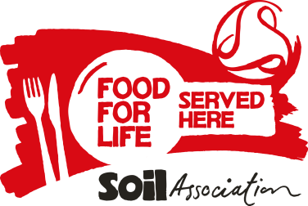**Food for Life Supplier Declaration – Additives and Trans fats**

In order to meet Food for Life Served Here standards, all ingredients served on accredited menus must be free from trans fats and the undesirable additives in the table below.

**Section 1 – Details of products**

Name of Caterer supplied:

Please tick as appropriate:

All products supplied are free from the additives and trans fats detailed here.

**or**

I attach a list of products supplied which are free from the additives and trans fats detailed here.

**Trans fats**

Trans fats or trans fatty acids (TFAs) are chemically altered vegetable oils, used to give processed foods a longer shelf life. They are produced artificially by a process called hydrogenation which turns liquid oil into solid fat. They can be found in partially hydrogenated vegetable oils used for frying and baking and found in some processed foods, margarines, cakes and biscuits and readymade mixes for cakes.

**Section 2 - Declaration**

* I declare that I hold evidence to support the claims specified above.
* I undertake to produce adequate documentation to demonstrate that all such products meet the above criteria, if requested.

|  |  |
| --- | --- |
| Name : | Signed:        I have completed this form electronically and am in agreement |
| Organisation: | Date: |

Please see the Food for Life Served Here handbook (Standard 1.5) for further details <http://www.sacert.org/catering/standards/bronze> or contact 0117 914 2406 if you have any questions.