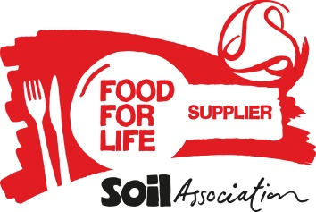**Food for Life Supplier Declaration – Free Range Eggs**

In order to meet Food for Life Served Here standards, all eggs served on accredited menus must be Free Range.

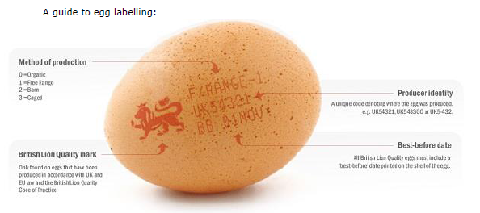**Section 1 – Details of Eggs**

Name of Caterer supplied:

Please tick as appropriate:

All eggs supplied to the caterer above are free range.

In addition to this I can confirm that all eggs supplied are:

Organic

**Section 2 - Declaration**

* I declare that I hold evidence to support the claims specified above.
* All products supplied to the caterer above will conform to these specifications unless and until otherwise stated.
* I undertake to produce adequate documentation to demonstrate that all such products meet the above criteria, if requested.

|  |  |
| --- | --- |
| Name : | Signed:  I have completed this form electronically and am in agreement |
| Organisation: | Date: |

Please see the Food for Life Served Here handbook (Standard 1.4) for further details <https://www.soilassociation.org/certification/catering/business-support-for-award-holders/standards/> or contact 0117 914 2406 if you have any questions.