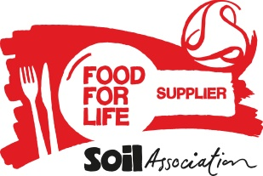**Food for Life Supplier Declaration – Marine Conservation Society ‘fish to avoid’ list**

In order to meet Food for life Served Here standards, no fish served can appear on the Marine Conservation Society ‘fish to avoid’ list.

Fish on the Marine Conservation ‘Fish to Eat’ List or which is accredited by the Marine Stewardship Council score points at Silver and Gold.

[](http://www.google.co.uk/url?sa=i&rct=j&q=&esrc=s&source=images&cd=&cad=rja&uact=8&ved=0CAcQjRw&url=http://www.sustainweb.org/sustainablefishcity/about/&ei=8AJ3VdzTI5Kf7gbc6IOYAQ&psig=AFQjCNH26f9DqIe4OOtj2uzrxXeTwRJfqw&ust=1433949293504658)**Section 1 – Details of fish supplied**

Name of Caterer supplied:

Please tick as appropriate:

All the fish and fish products supplied do not appear of the Marine Conservation Society ‘fish to avoid’ list

In addition to this I can confirm that the fish and fish products on the attached list are also either:

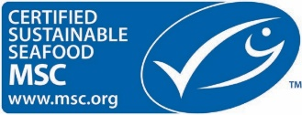 Marine Stewardship Council certified or on the Marine Conservation Society ‘Fish to eat’ list (Please attach list)

**The MCS ‘Fish to Avoid’ and ‘Fish to Eat’ List can be checked on the MCS website here:** [**http://www.fishonline.org/fishfinder**](http://www.fishonline.org/fishfinder)

**Section 2 - Declaration**

* I declare that I hold evidence to support the claims specified above.
* All products supplied to the caterer above will conform to these specifications unless and until otherwise stated.
* I undertake to produce adequate documentation to demonstrate that all such products meet the above criteria, if requested.

|  |  |
| --- | --- |
| Name: | Signed: |
| Organisation: | Date: |

I have completed this form electronically and am in agreement

Please see the Food for Life Served Here handbook (Standard 1.3 & 2.1.3) for further details <https://www.soilassociation.org/certification/catering/business-support-for-award-holders/standards/> or contact 0117 914 2406 if you have any questions.