**Cereal-Legume Intercrops**

Robin Walker (SRUC Aberdeen) & Ali Karley (JHI Invergowrie)

[robin.walker@sruc.ac.uk](mailto:robin.walker@sruc.ac.uk) OR [ali.karley@huttion.ac.uk](mailto:ali.karley@huttion.ac.uk)



There are currently a number of EU funded projects investigating diversification of agricultural production systems and inclusion of legumes as an approach to improve overall system sustainability. Two of these projects have major involvement from SRUC researchers (ReMIX) and researchers from JHI (DiVERSIFY), and in order to reduce the risk of duplication of resources between these projects, which have a strong focus on intercropping, collaborative approaches are being developed where appropriate. Some of this work also links into Scottish Government RESAS funded research.

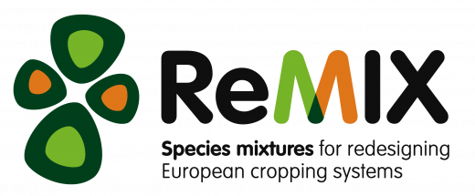 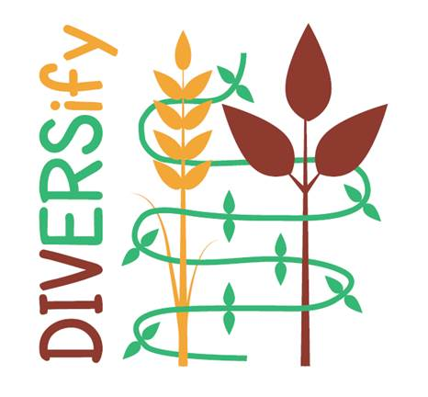

(<https://www.remix-intercrops.eu/>) (<https://www.plant-teams.eu/>)

**What is intercropping?**

Intercropping is essentially the cultivation of more than one crop species on the same area of land (some examples of this are shown in Figure 1). Previous research has shown that crop species mixtures - or intercrops can be adopted more widely to improve yield stability between seasons and locations, reduce pest and disease damage and enhance climate stress resilience in agricultural systems. Most crop species are, however, bred to perform well in monoculture, and there is limited information on suitable species appropriate for use in intercrops and even less information about the varieties that work well in these mixtures, especially if targeting a specific end use for grain, for example. This might be directed towards brewing or distilling, or as an alternative protein source to soya bean meal (SBM). In a cereal-legume intercrop, there may be no desire to take the crop mixture through to full grain maturity for combining, but early harvest as wholecrop, for example may be ideal as a home grown protein source for livestock.

**Figure 1:** A range of cereal-legume intercrops destined for protein to be harvested as both silage and grain productivity and tested for nutritional quality (pic courtesy of Dr Robin Walker, SRUC).

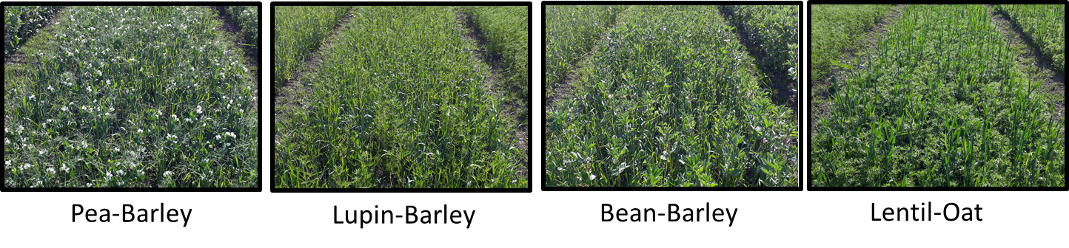

**Why consider using intercropping rather than monocropping?**

The ReMIX and DiVERSIFY projects are both investigating various aspects relating to the pros and cons of using intercrops compared to monocrops as part of EU wide project teams of researchers undertaking similar work in their own countries. A wide range of activities are taking place, from research that improves the mechanistic understanding of the interactions of various species and varieties in the intercrops and their environment (including modelling approaches) and provision of information to match species and variety characteristics for specific fields / farms / regions. Work on crop system productivity and yield quality improvement / issues, specialised harvesting machinery development, economic assessments and supply chain “issues” are also being done. Post graduate courses and a broad range of farmer focussed knowledge materials will be produced and delivered. Initiatives are also underway that include farmer participation experiments which have a co-design element, where ideas are discussed with / among farmers and researchers before intercrop mixes are grown on their own farm or on institute “hub” replicated trials.

**Potential benefits of characteristics in mixtures**

* Productivity (Table 1) - reports of a 15-30% increase compared to monocrop
* Resource use efficiency - better use of available light, water, nutrients
* Reduced leaching - legume N fixation stops if lots of crop available N in the soils
* Pest/disease suppression - less reliance on chemical inputs (pesticides)
* Weed suppression - less reliance on chemical inputs (herbicides)
* Attract beneficial organisms - pollinator and pest suppressing activity
* Soil quality improvement - N fixation

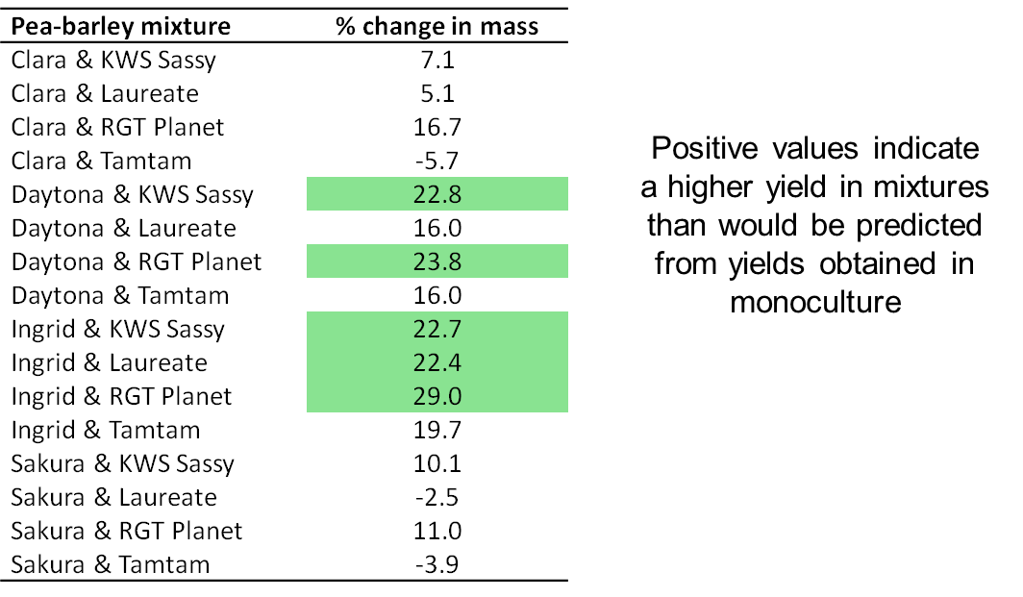

**Table 1:** Some recent productivity results from pea-barley intercrops grown for grain and combined (courtesy of Dr Adrian Newton, JHI).

As the projects develop, a range of KE material will be produced and made available to the wider public, including material developed to aid farmers develop their own systems for including intercrops.