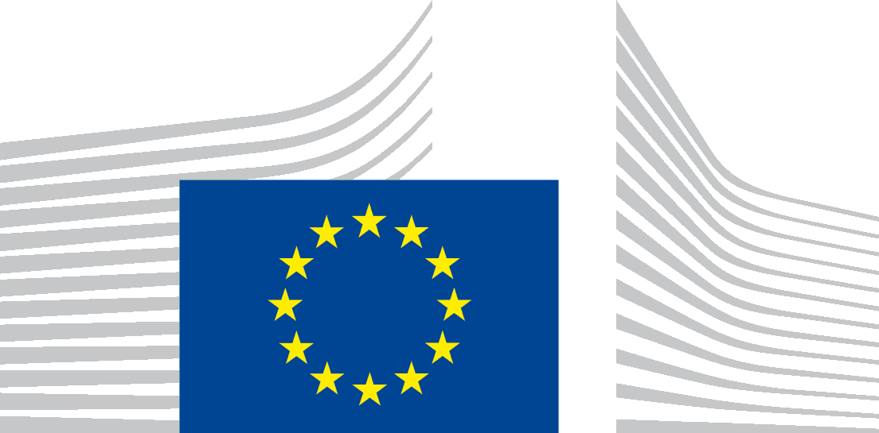 | EUROPEAN COMMISSION  DIRECTORATE-GENERAL FOR AGRICULTURE AND RURAL DEVELOPMENT
Brussels
AGRI.DDG1/MABS
Subject: Certificates of inspection for the import of organic products
Dear representatives of the Control Bodies,
In the context of COVID-19, we have been made aware that some of you are facing issues to ensure that the original of certificates of inspection accompanies the consignment and is presented to the relevant Member States authorities for endorsement before the release of the goods for free circulation in the EU market. This seems to be due to the serious restrictions applied to airplane transport and affecting the courier services used to deliver those paper certificates, as a consequence of the measures introduced to protect human health.
In case you are prevented from providing for a printed and hand-signed copy of the certificate of inspection due to the exceptional circumstances linked to COVID-19, I invite you to continue issuing the certificate of inspection in TRACES and to validate Box 18.
In addition and purely as a temporary working solution to prevent disruptions of trade, the competent Member States authorities agreed to accept to perform their documentary checks based exclusively on the information available in TRACES . The Member States authorities will endorse the certificate in TRACES by validating Box 20.
The temporary working solution proposed above is only intended to cover the contingency situation linked to the current COVID-19 pandemic and it should ONLY address the most urgent needs linked to COVID-19.
It will be in place until the 31 May 2020. The Commission will revisit the situation in due time.
I will keep you informed when arrangements may be reviewed in the light of further evolutions of the situation.
Yours sincerely,
María de los Ángeles BENÍTEZ SALAS

