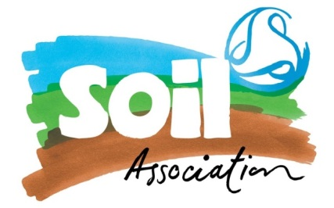
Equal Opportunities Monitoring Form

At the Soil Association we are committed to the promotion of equality in the workplace and we recognise the value that diversity brings to our organisation. We would be grateful if when applying for our job opportunities, you could please complete this monitoring form if you feel comfortable in sharing your personal information with us. The information will be treated in the strictest of confidence, your form will be detached from your application and handled by HR in accordance with the Equality Act 2010 and Data Protection Act 2018.

The usefulness of the data that we obtain through monitoring in this way is to help us understand the impact of our recruitment and selection policy in relation to equality & diversity and help us to identify ways to be more inclusive. The information you provide on this form will be held in the strictest confidence and only be used for the purpose stated above.

Post you are applying for:

Please can you tell us where you found the advert for this:

Our website
- Indeed
- Environment Jobs
- Charity Job
- Ethical Jobseeker
- Roots to Work
- Google Search
- Guardian Jobs
- Referred by a friend/ colleague
- Other, please state:

Age Please tick the box that describes your age group in years

16-17 |  | 18 – 20 | 21-24 |  | 25-29
30-44 |  | 45-59 | 60-64 |  | 65 and above
Prefer not to disclose

Disability
Under the Equality Act 2010, a person is considered to have a disability if she/he has a physical or mental impairment which has a substantial and long-term adverse effect on her/his ability to carry out normal day-to-day activities.

Do you consider yourself to have a disability?

Yes | No |  |  | Prefer not to disclose
Accommodating you in the interview & selection stages
We would like to ensure that you are given every opportunity to demonstrate your skills and experience in the recruitment and selection Process. Please can you let us know of anyways that you would like us to accommodate you in the potential interview and testing process?
- Ethnicity
(Please tick the box you consider to best describes your ethnic group)
Black or Black British |  |  | White
African |  |  | British
Caribbean  Other (please specify): |  |  | Irish
Asian or Asian British
Indian
Pakistani |  |  | White Other
Bangladeshi |  |  | Greek/ Greek Cypriot
East African Asian |  |  | Turkish
Other (please specify below): |  |  | Turkish/Cypriot
 |  |  | Kurdish
Gypsy/Roma
Irish Traveller

Other (please specify below):

Mixed |  |  | Chinese or Other Ethnic Group
White and Black African |  |  | Chinese
White and Black Caribbean |  |  | Any other ethnic background  (please specify):
White and Asian
Other (please specify): |  |  | I would prefer not to disclose

Gender

Please tick the box that best describes your gender
Male Female |  |  | I would prefer not to disclose
Thank you for completing and returning this form.

