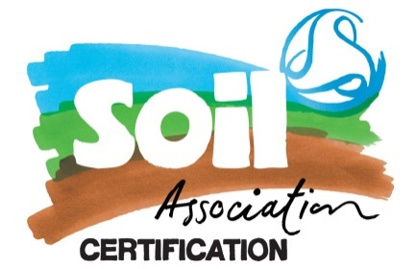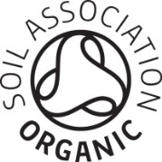

**Template for Description of Importing Activities for Organic Products from non-UK Countries**

Complete & submit this form to provide details of your importing activities as required by [Soil Association standard 6.8.5](https://www.soilassociation.org/our-standards/read-our-organic-standards/food-drink-standards/) and UK reg 889/2008 article 82.

**If you are importing into Northern Ireland - Certificates of Inspection (COI) required**

Each consignment imported into Northern Ireland (or elsewhere in the EU) from non EU countries (including GB) will require a COI. This will need to be endorsed by the exporter’s certification body in the non-EU country.

The COI is issued via the TRACES system, it must be completed electronically. You will need to make your supplier aware of the requirement for a COI and ask that they provide one for each consignment. You will also need to register as an importer and/or first consignee on TRACES, and notify the Port Health Authority (PHA) where the consignment will clear to enter Northern Ireland (or the EU).

**If you are importing into GB - GB Certificates of Inspection (GB COI) required**

Each consignment imported into GB will require a GB COI. This will need to be endorsed by the exporter’s certification body in the non-UK country (this may be an EU country or a country outside the EU). Imports from all non-EU countries require a GB COI from 1st Jan 2021, and from 1st February 2027 imports from EU countries, **Norway, Iceland, Liechtenstein and Switzerland** will require the same.

The GB COI is not issued via the TRACES system or any online platform;it is a word document that can be completed online. You will need to make your supplier aware of the requirement for a GB COI and ask that they provide one for each consignment

* You will need to notify the Port Health Authority (PHA ) where the consignment will clear to enter GB, and provide them a copy of the GB COI, this can be a PDF signed copy.
* Once the COI has been endorsed by the PHA and the consignment cleared the GB COI will need to be forwarded to the first consignee, and then to the certified importer all this can be done digitally.

For more information and detailed guidance relating to importing organic products see our [website](https://www.soilassociation.org/certification/food-drink/certification-resources/importing/).

**Please provide a description of:**

|  |  |
| --- | --- |
| Your premises  (the premises where we can carry out a physical inspection of your importing activities) | Click or tap here to enter text. |
| Your importing activities, including the locations where the products first enter | Click or tap here to enter text. |
| Any other facilities you intend to use for storage of imported products before they are delivered to the first consignee* (which may or may not be you). | Click or tap here to enter text. |
| The first consignee(s), including details of the facilities used for reception and storage of imported goods.  The first consignee must check that:   * the goods arrive in packaging/containers which prevent substitution /contamination, * the exporter is indicated * there is a lot number marked * a certificate of inspection is in place covering the goods received   A contracted warehouse may complete these checks on your behalf provided you verify these checks are being carried out correctly, and the warehouse is subject to a physical inspection by us as your organic certifier | Click or tap here to enter text.  **If you act as the first consignee at the premises described above tick here** |
| Your procedures / quality systems for ensuring that:   * COIs are requested from your non UK suppliers * Port Health Authorities are notified and provided a signed PDF copy of the COI * The First Consignee receives a copy of the COI and endorses the relevant section * As the importer you retain a copy of the endorsed COI | Click or tap here to enter text. |

* First consignee is defined as the first company / person to receive the consignment for storage, further preparation or processing. These activities require certification

|  |  |
| --- | --- |
| Do all storage sites you use hold a current organic certificate? | **Yes:**  **No:**  **Certificate number & issuing body:** Click or tap here to enter text. |