**Conversion Guide - Arable**

**The conversion process and planning when to start**

The conversion period for land is normally two years. Conversion can start once we receive a completed application form.

To sell products as ‘organic’, annual crops must be sown into land that has completed the conversion period. Crops harvested during the second year of conversion can be sold as ‘in conversion’.

Starting conversion before sowing the main autumn or spring crops – depending on your cropping plan – will ensure an organic crop as soon as possible after completing conversion.

Once conversion begins, the land and crops must be managed to full organic standards.

It can be possible to convert only part of a farm and in some circumstances Defra can give permission for the conversion period to be reduced, but please contact us to discuss the requirements for this.

**Crop management plan**

A crop management plan must be drawn up, we provide a [template](https://www.soilassociation.org/certification/farming/licensee-resources/certification-forms/) for this.

**Suitable varieties**

Choose species and varieties that are most suited to your environmental conditions and resistant to pest and disease threats to your crops as well as meeting your market needs.

**Seed**

Organic seed must be used if it is available. There is extensive availability of organic seed for most species and these are all listed on the UK database of organic seeds www.organicxseeds.co.uk. Approval can be granted for untreated, non-organic seed only if there is sufficient justification that the organic varieties available are not suitable for your needs; this approval must be given before you use any non-organic seed.

**Crop rotations**

A good rotation can balance demands on the soil and meet the nutritional requirements of a sequence of crops. It keeps nutrient loss to a minimum and helps build soil fertility. It also helps to limit the spread and persistence of pests, diseases and weeds. Care must be taken so that cultivations needed for one crop do not damage soil structure for future crops. Since continuous arable cropping does not meet the organic standards, organic arable rotations include a fertility-building phase (for example green manures or leys that include legumes).

**Soil management**

Organic arable farming focuses on maintaining a healthy and fertile soil to provide plant nutrition and health primarily through the soil ecosystem. For an organic system to function, cultivation practices need to maintain and increase soil organic matter, soil stability, biodiversity and prevent soil compaction and erosion.

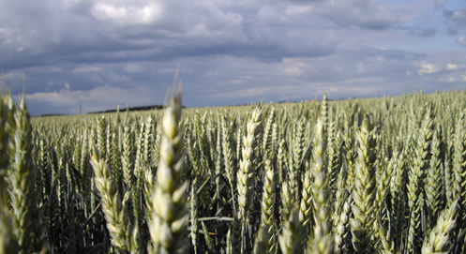

**Crop nutrition**

Nutrient availability depends on many factors including soil pH, soil structure, root depths and geology.

Where possible within a rotation legumes should be used and plant and animal wastes recycled to reduce the need to buy in nutrients. Additional crop needs should be identified through analysis and nutrient budgeting. If you buy supplementary nutrients in, please check (or ask us to check) that they contain only ingredients that are permitted for organic growing (these are listed in section 2.5 of [Soil Association standards](https://www.soilassociation.org/media/15931/farming-and-growing-standards.pdf)). Some composts, substrates and fertilisers are sold as ‘organic’ but they are not suitable for organic production so it is important to always check. If prohibited substances are used the crops cannot be sold as organic and the land may need to reconvert.

Some natural organic fertilisers and supplementary nutrients can be permitted as a last resort, but proof is needed that there is a deficiency. Artificial nitrogen fertilisers and any human-based waste such as sewage sludge are strictly prohibited.

**Pest and disease management**

Cultural controls and prevention are key to organic crop protection. Combinations of the use of resistant varieties, strategic sowing times, crop rotations, frequent monitoring, physical barriers and the encouragement of natural predators for pests all help to prevent significant crop damage. Although, even with these measures in place there may still be the need to use additional pest control products.

There is a limited list of pest control products that can be used by organic farmers (these are listed in section 2.6 of the [Soil Association Standards](https://www.soilassociation.org/media/15931/farming-and-growing-standards.pdf))

**Weed management**

Weed control requires careful management in organic systems as all herbicides are prohibited. Cultural and mechanical methods therefore need to be planned, to prevent weeds affecting your crops. This may include pre-emergence and post-emergence mechanical operations and thermal weeding.

You can refer to section 2.6 of the Soil Association standards; and we can direct you to crop-specific guidance.

**Every farm is unique, contact the Go Organic team on 0117 914 2406**

We’re happy to discuss the certification process, organic standards, grant payments, organic market support and how it all could apply to your farm.

[goorganic@soilassociation.org](mailto:goorganic@soilassociation.org) [www.soilassociation.org/organicfarmingcertification](http://www.soilassociation.org/organicfarmingcertification)

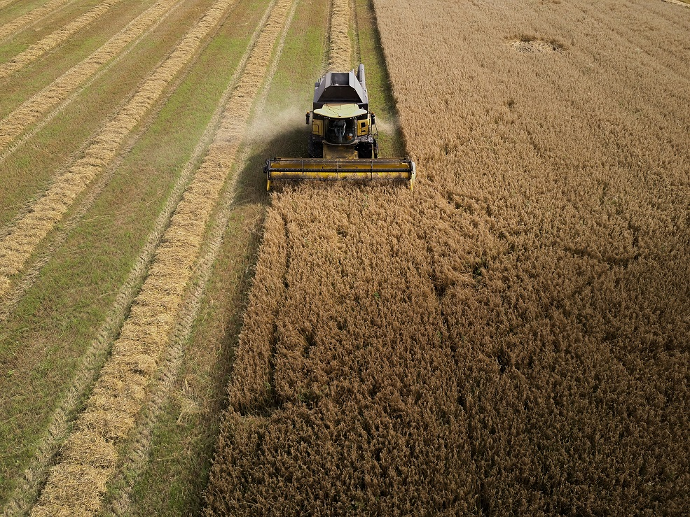

**Organic markets and grant schemes**

Before converting, it is wise to identify a market and plan the business model, crops and varieties accordingly. We publish up-to-date arable prices on our website and can give you contact details for organic grain traders.

In most of the UK, [organic payments](https://www.soilassociation.org/farmers-growers/market-information/financial-information/) are available annually from devolved governments.

**The certification process and inspections**

Organic certification includes a physical inspection every year to look at land, crops and records to verify that all organic production rules have been met. We may take samples for testing and can carry out more than one inspection per year. A new organic certificate is issued every year after successful inspection and certification.

