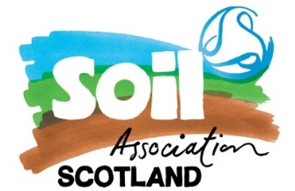Pork tasting session: the results

Key:

Feed types **a =** 100% ‘normal’ (proprietary) feed; **b =** 50% proprietary feed /50% barley + ad-lib silage

Like-ability score **1** = least like-able; **5** = most like-able

|  |  |  |
| --- | --- | --- |
|  |  |  |
|  |  |  |

**So… it looks like a pretty close-run thing. There was no overall preference for one or the other, and in terms of flavour, an equal amount of people rated both as 5 (most like-able). This indicates that the different feeding regimes had little discernible effect on meat quality.**