***Weight gain results***

*The Feeding Silage to Pigs field lab is running at Peelham Farm from 2014-2016. It is investigating if including silage in pig rations can:*

* ***Reduce production costs*** *(in order to improve financial resilience)*
* ***Reduce the reliance on soya as a source of protein*** *(in order to reduce the environmental impacts associated with soya production, and so improve environmental resilience)*
* ***Improve gut health*** *(in order to improve livestock resilience through promotion of health)*

**Trial setup**

Two groups of pigs of the same age, sex, and breeds (a mixture of Duroc crosses and Tamworth crosses) were fed two different rations. The control group were fed a ‘normal’ ration of ad-lib proprietary pelleted feed (which includes wheat and soybean meal). The experimental group were fed a 50%/50% mixture of ad-lib proprietary feed and (home produced) barley, with ad-lib red clover silage. This ration increased the proportion of energy (from the barley), and so decreased the protein proportion, giving the pigs an incentive to seek out protein, and actually eat the silage.

**Results: weight gain**

Weight gain was not significantly different for the Duroc cross pigs fed either ration. There was more of a difference in weight gain for the Tamworth cross pigs, however this was not significant when comparing weight gain from the different rations. There was a significant difference in weight gain between the ‘big’ and the ‘small’ Tamworth cross pigs.

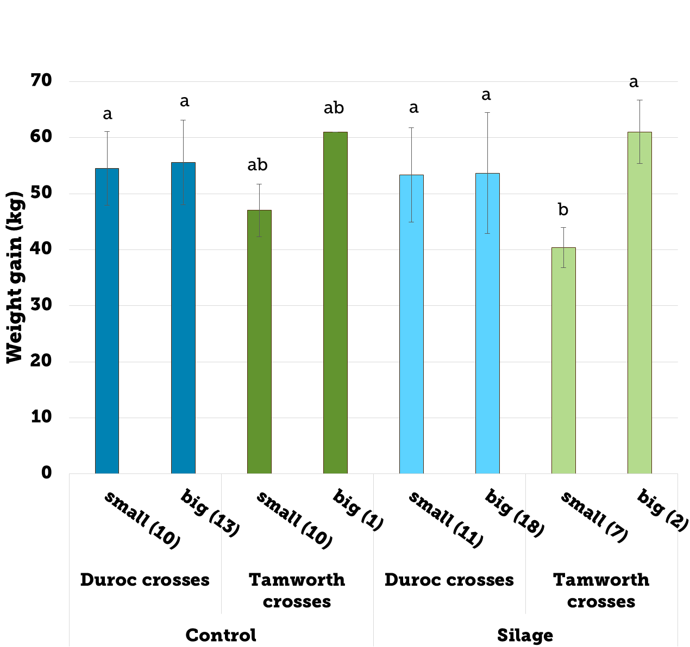

Figure 1: weight gain in Duroc and Tamworth cross pigs fed different rations

**Discussion**

The expectation was that reducing protein supply for smaller pigs with the potential to grow faster (Duroc) might be more of a challenge than for the bigger more traditional Tamworth pigs. This was not the case at all, and the smaller Duroc pigs actually performed well on both diets.

Our study was different to others as it restricted protein: giving an incentive for the pigs to explore and seek other forms of protein. The silage would have provided this. There is also the possibility that the pigs seeked and consumed more invertebrates, which provide good quality protein.

**Conclusion**

Our results indicate that feeding silage to pigs, rather than a standard diet, did not negatively impact on weight gain. For the Duroc cross pigs there was no significant difference in weight gain between the two diets. An earlier meeting that included a pork tasting session found that that feeding silage to pigs is not detrimental to [pork quality](http://www.soilassociation.org/LinkClick.aspx?fileticket=s6a7I3rQHXE%3d&tabid=2386).

**The weight gain and pork quality findings from this field lab indicate that there is potential to reduce imported protein by using home grown silage to feed pigs.**

***Next steps***

This field lab will potentially be scaled up as a much larger research project with Newcastle University. The financial and animal health impact of feeding silage to pigs will be looked at in more detail. The following assessments will be made.

* ***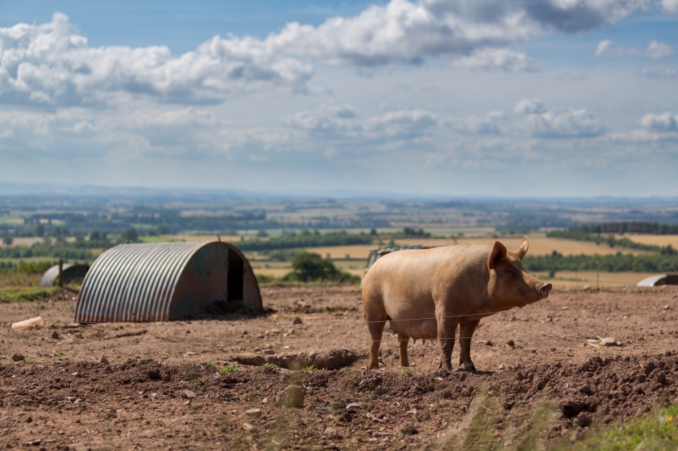*Killing out percentage** – how much of the carcass (as a % of the weight of the live animal) is sellable meat?
* **Cost per kg of liveweight gain** – what did the different rations actually cost, in terms of how the pigs performed (i.e. put on weight) on them?
* **Carcass grade** – what was the quality of the carcasses, did they meet the abattoir’s specification, or did they receive a penalty because they did not meet the specification?
* **Gut health –** is there a difference between the gut lengths of pigs fed the different rations?

Thanks to Gillian Butler and Diane Holmes, NaffertonEcological Farming Group, Newcastle University, and Chris Walton, Peelham Farm, Berwickshire.