***Meeting 3: 2nd December 2015; Edinburgh New Town Cookery School***

*The Feeding Silage to Pigs field lab is running from 2014-2016. It is investigating if including silage in pig rations can:*

* ***Reduce production costs*** *(in order to improve financial resilience)*
* ***Reduce the reliance on soya as a source of protein*** *(in order to reduce the environmental impacts associated with soya production, and so improve environmental resilience)*
* ***Improve gut health*** *(in order to improve livestock resilience through promotion of health)*

The purpose of this meeting was to evaluate if feeding silage to pigs had any impact on meat quality. If the pork produced in this way is inferior, there is little point in continuing with the practice.

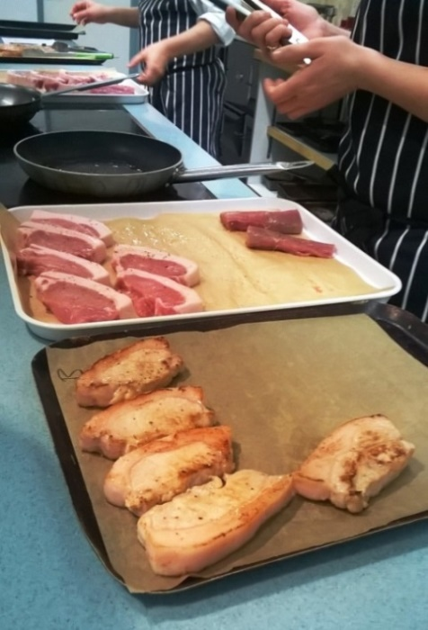**Background**

Since the last meeting the production part of the trial has been completed: two groups of pigs of the same age, and same mix of sexes and breeds were fed two different rations. The control group (pork A) were fed a ‘normal’ ad-lib ration of pelleted proprietary feed (which includes wheat and soyabean meal). The experimental group (pork B) were fed a 50%/50% mix of pellets and barley, along with ad-lib red clover silage. Increasing the proportion of energy in this ration gave them an incentive to seek protein, and eat the silage.

Previous field lab meetings have been held on-farm and have looked at pig production. This field lab was held at Edinburgh New Town Cookery School in the main teaching kitchen where the 15 participants got a chance to see, smell, and taste pork from the trial. Participants tasted the pork ‘blind’: they did not know which production system was used to produce either type.

**Quality testing criteria**

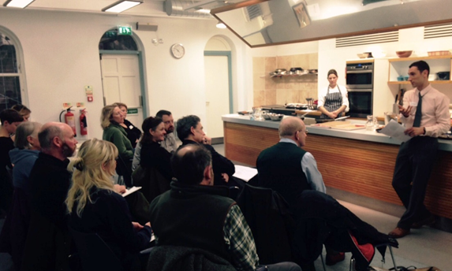Students and staff from Queen Margaret University’s [Gastronomy MSc](http://www.qmu.ac.uk/courses/PGCourse.cfm?c_id=270) took part in this meeting: students on the course (who were trained chefs) cooked, and Charlotte Maberly (Gastronomy programme leader) designed the quality assessment criteria:

1. Appearance raw
2. Appearance cooked
3. Cooking quality
4. Aroma
5. Texture in mouth
6. Flavour

**Results**

Overall there was no clear preference for pork from pigs fed silage or not. The comments for both types of pork were very similar. The full set of [results](http://www.soilassociation.org/LinkClick.aspx?fileticket=s6a7I3rQHXE%3d&tabid=2386) can be viewed here.

**Conclusion**

The results of this session indicate that feeding silage to pigs is not detrimental to pork quality. If clear financial, animal health, and environmental benefits can also be demonstrated then there is potential for silage to be fed to pigs commercially.

***Next steps***

Assessments will be carried out to determine the financial impact of feeding silage to pigs. The following things will be investigated to see what the differences are between feeding regimes:

* **Weight gain** – the amount of kilos the pigs gained in weight
* **Killing out percentage** – how much of the carcass (as a % of the weight of the live animal) is sale-able meat
* **Cost per gram of liveweight gain** – what did the different rations actually cost, in terms of how the pigs performed (i.e. put on weight) on them
* **Carcass grade** – what was the quality of the carcasses, did they meet the abattoir’s specification, or did they receive a penalty because they did not meet the specification

Several of the people involved in the field lab are looking to scale this up as a much larger research project with Newcastle University.

