 |  | 

Expanding Scottish split pea (and other pulses) production:
a pre-feasibility study

Andrew Moxey, Pareto Consulting
apmoxey@pareto-consulting.co.uk
Angela Tregear, University of Edinburgh
angela.tregear@ed.ac.uk

March 2026

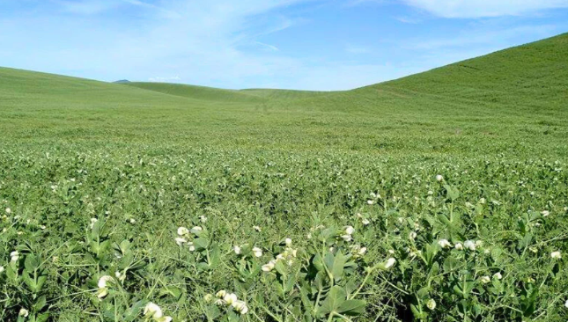 | 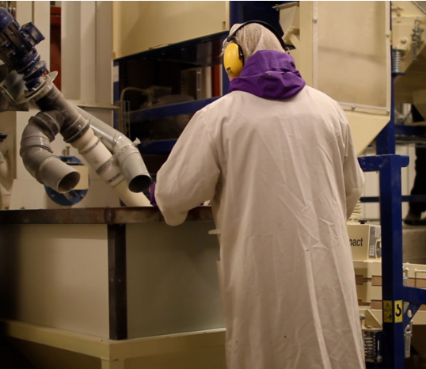 | 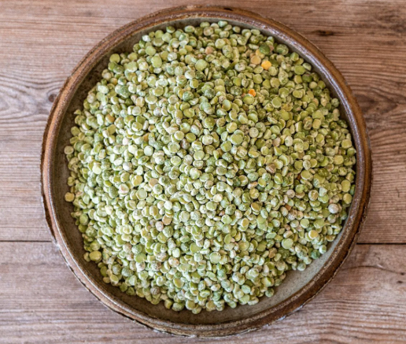 | 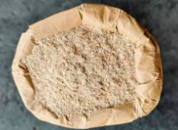

 |  |  |  | 

Expanding Scottish split pea (and other pulses) production: a pre-feasibility study
Introduction
- This report presents summary findings from a short, pre-feasibility study of expanding production of split peas and other pulses within Scotland. The study was commissioned by the Soil Association following its successful but small-scale ‘Give Peas a Chance!” pilot project which placed Scottish organic green split peas onto local school menus in North East Scotland.
- The study was undertaken between October and February 2026, by Andrew Moxey of Pareto Consulting and Angela Tregear of the University of Edinburgh’s Business School. The research process included a review of published academic and grey literature plus collation of insights offered by interviews with selected academic, policy and practitioner stakeholders. The following sections present summary findings, with some additional detail offered in the Annexes.
- The study was supported by the Scottish Alliance for Food which is funded by Scottish Funding Council grant H23050. The views expressed are those of the authors and not necessarily those of the Scottish Alliance for Food or the Scottish Funding Council. The pre-feasibility study was also supported by Bridging the Gap, a programme of Sustain: the alliance for better food and farming. The authors are grateful to the sponsors and interviewees for their participation and insights.
Background
- Numerous studies have shown that the cultivation of pulses as part of crop rotations offers public good environmental benefits as well as private production benefits. Similarly, other studies have shown that the consumption of pulses enhances human dietary-related health.
- For example, by reducing the need for artificial fertilizers and bought-in animal feed, peas and beans can lower pollutant loadings to air and water whilst also saving on input costs. Crop diversification also helps to support wider biodiversity and to reduce pest and disease burdens, further lowering required expenditure on chemical inputs. Such substitutions are inherently consistent with, albeit not restricted to, organic production systems. Equally, the nutritional profile of peas and beans contributes to a healthy diet as a source of protein, fibre and various micronutrients.
- Consequently, the production and utilisation of pulses within Scotland contributes towards a range of stated policy objectives. For example, the Agricultural and Rural Communities (Scotland) Act aims to simultaneously improve environmental conditions and farm profitability whilst producing high quality food, the Good Food Nation (Scotland) Act seeks to improve Scottish diets whilst improving the diversity and profitability of Scottish farming, and the Organic Action Plan aims to double the area under organic production.
Current position
- Pulse production in Scotland is currently very limited. For example, although slightly higher than a decade ago, only c.10k ha of peas and beans were cultivated in Scotland in 2024, across c.1k farms. This contrasts to c.250k ha of barley and c.100k ha of wheat.
- Equally, pulses do not currently feature prominently in Scottish diets. For example, average per capita consumption in 2024 was one portion per week (of which, most is accounted for by baked beans).
- This position reflects several inter-related trends. In particular, whilst pulses were once commonly grown on-farm under rotational crop practices, farming systems have instead become reliant upon artificial fertilisers and a relatively narrow range of crops. This system shift has also directed research and development and advisory support away from pulses, amplifying current unfamiliarity with pulse production and farmer perceptions of relatively low and unpredictable yields.
- Equally, replacing imported soya beans in animal feed has been hampered by unfamiliarity with how to cultivate and use domestic pulses, plus soya’s higher protein content which facilitates greater and more cost-effective growth for a given volume of feed intake.
- Similarly, whilst pulses were historically a regular feature of Scottish diets, consumer research shows that many (but not all) current consumers perceive pulses as inferior to animal proteins in terms of taste, texture and convenience.
- Current average consumption of less than one portion of pulses per day compares to seven per day recommended in the EAT Lancet Planetary Health Diet. Teenagers and adults eat less than younger children, but high-income consumers and people from Asian backgrounds eat more pulses than the average.
- This low level of demand at least partly reflects a degree of widespread unfamiliarity stemming from systemic differences in consumers’ relative understanding of, and access to, different food products. However, research also shows that more positive attitudes and behaviours can be encouraged through increased information, culinary confidence and exposure to pulses.
- In addition, although primary production and market demand are both necessary, a degree of processing is also required prior to consumption. However, there are currently no primary processing facilities for pulses within Scotland offering the scale likely to be needed for a significant expansion in domestic production and utilisation. This at least partly reflects a lack of confidence that any investment in processing will secure adequate throughput given current levels of on-farm cultivation and market demand.
Options moving forward
- Expanding Scottish production and utilisation of green split peas and other pulses aligns with policy ambitions but faces some challenges. However, insights gleaned from stakeholders and published literature suggest ways in which progress could be made by addressing issues at different points along the supply-chain.
- Importantly, inter-dependencies across the supply-chain mean that multiple actions should be taken simultaneously. This suggests that a system-level approach may be needed, with a potential role for either a lead/anchor firm or cooperative body as well as government support.
Upstream
- The focus of plant breeding efforts on cereal and oilseed crops in recent decades has diminished the attention paid to pea and bean varieties in the UK. Consequently, available varieties are not necessarily best suited to current conditions and market demands.
- For example, in terms of resistance to pests and diseases, characteristics needed for consistent processing, and consumer tastes. Similarly, the availability of information, advice and training for those farmers considering cultivating peas is constrained by service providers’ current focus on other more dominant cropping enterprises.
- To an extent, these issues are already being addressed within voluntary networks. For example, peer-to-peer engagement amongst like-minded farmers to share ideas and experience, sometimes facilitated by third-sector organisations and with the involvement of academic researchers. Such activities are commendable and should continue, possibly leading to more formally constituted cooperative entities.
- However, there is also a role for complementary policy support in the form of more explicit ring-fenced funding to bolster domestic capacity in Research & Development (R&D) and Knowledge Transfer (KT) related to pulse production.
- For example, within the Scottish Government’s Strategic Research Programme (SRP) and the Farm Advisory Service (FAS). This could take different forms but would help to correct the current imbalance towards other crops and farm enterprises, with a focus on climate resilience, protein content and rotational benefits.
On-farm
- More readily available information, advice and training, plus pea and other pulse varieties better suited to current farming and market conditions should enhance willingness amongst farmers to consider cultivating such crops. For example, through greater confidence in how to achieve reliable and reasonable yields plus a better understanding of the cost savings across a rotation. Clearer guidance on management choices would help to improve quality and consistency for subsequent processing.
- Yet farmers also require some reassurance about financial returns to production. This is more likely in the presence of robust market outlets offering appropriate farmgate prices, which highlights the need for access to processing facilities and (ultimately) actual demand for split peas and derived products (see also below).
- However, there is a potential role for policy in the form of direct support for cultivation. For example, as in some other countries (including Northern Ireland), growers of pulses could receive a direct payment per hectare. Such payments ensure a minimum level of revenue irrespective of yields or prices and can reduce the perceived riskiness of cultivating peas whilst processing and markets are still developing.
- It should be noted that alternative policy mechanisms can also be used to incentivise cultivation in other ways. For example, Greening obligations under the Common Agricultural Policy (CAP) have been used to encourage pea and bean cultivation by limiting alternative crop choices and/or requiring greater crop diversity. Although no longer under the CAP, Scottish agricultural policy can still deploy such measures.

Processing
- Harvested peas require processing prior to consumption. For animal feed uses, at minimum, this entails cleaning prior to feeding on-farm, although at least cracking the hulls improves digestive utilisation for ruminants and further grinding is required for pigs and poultry. Full dehulling improves the protein concentration, which may be important given that soya beans (currently widely used in animal feed) offer protein levels almost double those of peas and beans and are currently perceived as a more cost-effective source of protein per unit of feed intake.
- For human consumption, dehulling and ideally splitting is required, followed by further cleaning and grading. The latter improves quality by achieving a greater uniformity of colour and size prior to bagging. Dehulling and splitting can require multiple passes through machinery, and inconsistency in the size and moisture content of raw peas and beans can significantly affect wastage rates and therefore financial performance – highlighting that correct cultivation and harvesting of suitable varieties is very important.
- From a technical perspective, commercial equipment manufacturers confirmed in interviews that small-scale processing to produce bagged split-peas is perfectly feasible. Indeed, existing set-ups exist outwith Scotland and could be replicated for around £20k+VAT for design and installation and £60k+VAT for the equipment. On-site storage, to smooth the imbalance between harvesting at one point of the year and utilisation over the year for harvested and/or processed peas would be extra, as would a building to house the equipment - -implying around £100k + VAT overall for the smallest-scale processing set-up.
- However, even at this smallest scale equipment has a daily throughput requirement of c.2t and needs sustained use through the year to be financially viable, with harvest seasonality requiring storage for harvested as well as processed peas. For example, an illustrative average yield of under 3t/ha and an operational target of c.220 days/year implies c.150 ha of peas would need to be grown in Scotland for this purpose to justify this minimal level of processing investment. This makes cooperative, multi-farm arrangements more realistic than isolated investment by individual growers (not least since pulses are grown on rotation, so the total farm area required is higher). Ambitions for Scottish production beyond this level would imply multiple small-scale processors or a single but larger plant, which would be a key choice to be made.
- Throughput and hence viability could also potentially be enhanced by additionally handling different crops, given that cleaning, sorting, grading and bagging operations are more or less common across all crop species. However, non-pulse crop species could either require tedious reconfigurations of some equipment and/or additional equipment. Moreover, the handling of pulses and non-pulses in the same space could raise allergen concerns.
- Further processing into flour, or into protein and starch isolates as functional ingredients, requires additional equipment. Internationally, several very large investments have been announced recently for functional ingredient processing, with annual throughput capacities of 40,000 tonnes or more, and upfront capital costs of up to €100m (encompassing both primary and secondary processing). This scale is unlikely to be achievable in Scotland. Primary processing plants with a throughput of 10kt – 15kt require c.£3m of upfront investment.
- Rather than invest in a new bespoke processing facility, an alternative would be to use an existing processor on a contractual consignment basis. This was the approach taken for the ‘Give Peas a Chance!’ pilot. Unfortunately, at present, although some secondary processing does occur in Scotland and there may be some unrecorded on-farm processing of home-grown pulses for animal feed, there does not appear to be any primary processing facility for dehulling and splitting for human consumption purposes.
- However, processing of other crops does occur in Scotland, and it is possible that one or more of these businesses would be interested in diversifying into pulse processing. Much would depend on anticipated volumes and the level of additional equipment investment required.
- Separately, a pulse processor interviewed for this study and currently based in England may relocate to Scotland as part of broader expansion plans and would be prepared to take relatively small volumes of peas for splitting on a service contract basis. This would retain greater added value within Scotland, and reduce transport costs and emissions.
- In all cases, British Retail Consortium (BRC) certification would be required for food grade production. Equally, organic certification would also be needed where desired – although meeting throughput requirements could need any facility to handle both organic and non-organic materials. The organic status of current pulse production across Scotland is unknown, but the availability of organically-certified primary processing (currently all outwith Scotland) is known to be limited, as is the availability of organically-certified secondary processing within Scotland. However, seeking organic certification for primary and/or secondary processing would not necessarily be a binding constraint, albeit another administrative burden.
- Additional processing capacity, whether on-farm, cooperatively or under contract, would be encouraged by upstream production and by downstream market developments. However, policy could also play a direct role via grant-aid and advisory support for business planning. Equally, encouragement for circular economy reductions in waste and/or product reformulation to reduce reliance on imports or contribute to healthier end-products would also be supportive.
Market outlets
- As noted above, domestically produced peas have potential market outlets as either animal feed or human food. Both categories can be further sub-divided, reflecting more specific user requirements and degrees of processing.
- For example, animal feed outlets include cattle and sheep plus pigs and poultry, but also aquaculture and household pets. Consumer uses include minimally processed products, such as split peas, but also further processed and manufactured products such as flour, snacks and prepared meals. The latter may also utilise protein and starch isolates and concentrates extracted from peas as functional ingredients.
- As the success of the ‘Give Peas a Chance!’ pilot shows, it is possible to stimulate reasonable uptake of pea-based menu choices through imaginative recipes, positive on-site consumption messaging, and support for staff. In principle, this approach could be replicated for schools across all of Scotland, and/or extended to other public sector catering venues such as hospitals. However, Local Authorities and NHS Trusts may require additional budgetary support and/or support from procurement teams and contracted wholesalers to ensure access to the product.
- More importantly, whilst acting as a visible symbol of policy intent, public sector catering represents a much smaller share of food consumption than private sector catering and in-home consumption. Consequently, private consumption has greater scale and growth potential.
- However, per capita consumption is very low and dietary preferences are complex and challenging to shift. The routine use of pulse flour in (e.g.) bread would significantly increase demand for peas and beans, as would widespread substitution of them for soya in animal feed. As yet, no large-scale retailers or manufacturers have committed to such changes.
- Encouragement to consumers to change can be offered through information and advice, including public dietary guidance and education but also third-sector and/or private marketing. For example, the Food Foundation’s current ‘Bang in Some Beans’ campaign.
- Uptake may also be encouraged by new product development, to offer consumers more appealing pulse-based products. Such efforts are likely to be primarily driven by commercial entities, but public support has a role to play in offering advice and funding. For example, in relation to supporting product reformulation and waste reduction, or publishing official dietary guidance (e.g. as in Denmark, Flanders, and Sweden). Pulse flour is currently being trialled in bread products in the UK.
- At least in the first instance, seeking to expand animal feed utilisation may be easier than developing consumer markets. This partly reflects less complex processing requirements, but also the current drive to reduce reliance upon imported soya protein linked to environmental degradation abroad (e.g. in Latin America).
- In principle, with care, output from animal feed processing can be further processed for human consumption, meaning that entirely separate processing facilities are not necessary. It should also be noted that by-products from processing can also have value as animal feed.
Protein strategies
- The governments of some other European countries have used protein strategies to encourage and co-ordinate actions across different parts of the supply-chain.
- For example, public behavioural change campaigns, public procurement targets, provision of market intelligence, circular economy waste reduction targets, grant-aid for processing facilities and new product development, area payments for cultivation, knowledge transfer, funding for upstream R&D and advisory service capacity, and support for academic spin-off companies, plus cooperative or joint-venture enterprises.
- A similar holistic approach could be adopted in Scotland, or the UK. Figure 1 summarises the supply-chain and potential actions along it. Table 1 lists some potential options for configuring processing.

Next steps
- The insights gleaned from published literature and stakeholder perspectives confirm that expanding split-pea production in Scotland would be technically feasible and would align with multiple government policy objectives.
- However, as a pre-feasibility study, the findings are necessarily indicative and further investigation is required. Consequently, the following Next Steps are suggested:
- Consider and agree scale of Scottish ambitions and alternative organisational structures.
- Estimate capacity requirements and associated funding needed for improved upstream R&D and advisory services.
- Canvas interest amongst Scottish farmers for growing peas (and beans) for animal feed and/or human consumption, with and without accompanying support.
- Consider the merits of both animal feed and human consumption market outlets and then more formally approach existing agricultural cooperatives and/or SAOS, non-pulse processors within Scotland who might be willing to extend to pulse processing and to offer contract services, and the pulse processor in England considering relocating to Scotland. Clarify their throughput requirements, target price points, and certification requirements.
- Approach the Enterprise Networks and other arms-length public bodies (e.g. Opportunity North East) to clarify the availability of local support for processing facilities/innovation/new product development.
- Continue discussions with public sector caterers about further geographical and sectoral expansion of demand.
- Approach secondary processors, food product manufacturers and animal feed suppliers to establish interest in market development.
- Conduct research initiatives/programmes tried in other jurisdictions to stimulate demand
- Explore with Scottish Government officials and Ministers the appetite for establishing an explicit national protein strategy or narrower support measures to encourage establishment of a Scottish split-pea (or wider pulse) supply-chain.

Figure 1: Stylized split-pea supply-chain, with example activities (above) and possible protein strategy actions (below) at different stages

Seeds |  | Cultivation |  | Cleaning |  | Milling (flour) |  | Blending |  | Animal feed
Advice |  | Harvesting |  | Dehulling/splitting |  | Fractionalisation (isolates) |  | Product reformulation |  | Catering
Machinery |  | [Cleaning] |  | Cleaning/Grading |  | Bagging |  | New product development |  | Retailing
 |  | [Storage] |  | Bagging
Input suppliers |  | Growers |  | Primary processors |  | Secondary processors |  | Food & feed manufacturers |  | End markets
R&D capacity |  | Area payments |  | Co-operation |  | Capital grants |  | Innovation vouchers |  | Dietary guidance
KT capacity |  | KT support |  | Capital grants |  | Circular economy |  | Circular economy |  | Public procurement
Spin-offs |  | Co-operation |  | Market intelligence |  | Market intelligence |  | Market intelligence |  | Marketing campaigns

Table 1: Stylized options (not necessarily mutually exclusive) for configuring split-pea processing
Option | Considerations
A. Individual Scottish farmer invests in on-farm processing | Simple, but unlikely that a single farm will generate sufficient throughput to justify capital investment. Securing additional supplies to achieve cost-effective throughput an additional administrative challenge.
B. Cooperative group of Scottish farmers invests in centralised processing | More likely to achieve required throughput, albeit with additional coordination challenge. Requires demand reassurances.
C. Existing pulse processor accepts Scottish consignments | As per ‘Give Peas a Chance!’ Pilot. Avoids need for farmer investment but cedes all control to separate processor – with none (possibly one) currently in Scotland. Requires supply and demand reassurances.
D. Existing non-pulse processor invests in pulse processing and accepts Scottish consignments. | As above, but possibly greater number of potential candidates – including within Scotland. Possibly more relevant to secondary processors.

Annex A: On-farm cultivation and upstream input requirements
Based on background reading listed at end and, where indicated, pers. comms. with stakeholders
- Cultivation of peas within Scotland has averaged c.9.8k ha over the past five years, with beans averaging c.4.6k ha. The latter is split evenly between stockfeed and human consumption but pea production is mostly for human consumption (c.0.4kha for stockfeed), with almost all of the hectarage being for frozen vining peas. For comparison, the barley area is c.296k ha, the wheat area c.102k ha, and the oilseed area c.36k ha; improved grassland covers c.1.3m ha and rough grazing (including commons) c.3.6m ha.
- Prior to the Second World War, legumes were commonly included in grazing and cropping practices across Europe. However, encouraged by policy support, the subsequent rapid adoption of artificial fertilizers, mechanization, and new grass and crop varieties displaced legumes.
- The result was a dramatic increase in the yields achieved per hectare for crops such as wheat and barley, but also significant reductions in crop diversity, increased pollutant loadings to air and water, and poorer soil health. In addition, livestock production has become increasingly dependent upon purchased rather than home-grown animal feed, with imports – particularly soya beans – featuring prominently.
- Contemporary agricultural policies across Europe recognize and seek to mitigate these problems, including by encouraging cultivation of legumes. For example, including grain legumes in crop rotations improves crop diversity and hence general biodiversity. It also reduces reliance on artificial fertilizers, thereby avoiding some farm costs whilst also lowering GHG emissions from the manufacturing and application of artificial fertilizers and nitrate losses to water courses. In addition, output can save further costs on purchased feed and/or generate more diversified revenues through sales to feed and human food market outlets.
- However, the dominance of other cropping enterprises within contemporary farming systems means that there is a degree of unfamiliarity with growing grain legumes in Scotland. That is, farmers may lack the skills and confidence to (re)introduce peas and beans into crop rotations.
- For example, following the creation of Ecological Focus Areas (EFAs) under Greening requirements of the Common Agricultural Policy, some Scottish farmers attempted to cultivate peas and beans as the only cash crop permitted on EFAs. Unfortunately, many achieved disappointing yields and revenues and subsequently did not repeat the experiment (pers. comms).
- This highlights a need for access to appropriate information, advice and training for skills development and appreciation of the benefits to subsequent crops in a rotation (i.e. lower pest & disease burdens, reduced fertilizer costs). However, the absence of pulses from common farming systems means that advisory capacity for providing information and training about cultivating pulses is often lacking.
- Similarly, whilst appropriate management contributes to reliably high yields, so does choice of a plant varieties well suited to local growing conditions and market demands. Unfortunately, the dominance of a few other crop species means that plant breeding has focused more on non-pulse crops, such as barley, wheat and potatoes (and arguably even then often not with even a UK focus). Consequently, currently accessible pulse varieties may not be optimal for Scottish conditions.
- This highlights a need for upstream R&D activities to better match pea and bean varieties to current local growing and market conditions. Whilst this, and advisory support, can arise spontaneously through peer-to-peer networking, there is a role for public policy support to coordinate and/or fund capacity building.
- Beyond cultivation capabilities, farmers also require some reassurance about financial returns to production. This depends partly upon yield, which may be bolstered through better varieties and management, but also upon the costs of achieving the yield and the price that it then receives.
- Production costs are related to management, and so information, advice and training are also relevant here. However, farmgate prices depend upon access to markets and hence market outlets need to be developed – whether in the form of animal feed or food grade products.
- Moreover, because utilisation of pulses requires at least a minimal level of post-harvest processing, access to any ultimate end-users is generally mediated through processing intermediaries.
- However, separately, there is a potential role for policy here in the form of direct support as a means of derisking cultivation. For example, as in some other countries (including Northern Ireland), growers of pulses could receive a direct payment per hectare.
- Such payments ensure a minimum level of revenue irrespective of yields or prices and can reduce the perceived riskiness of cultivating peas whilst processing and markets are still developing.
- Equally, alternative policy mechanisms can also be used to incentivise cultivation in other ways. For example, Greening obligations under the Common Agricultural Policy (CAP) have been used to encourage pea and bean cultivation by limiting alternative crop choices and/or requiring greater crop diversity. Although no longer under the CAP, Scottish agricultural policy could still deploy such measures.

Map A1: Distribution of pea and bean cultivation within Scotland, 2024
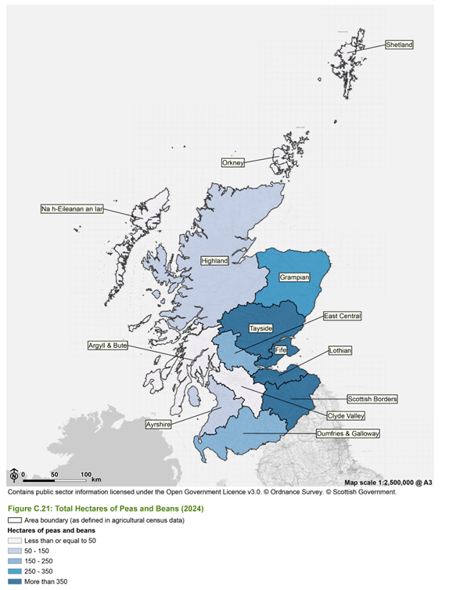
Source: SEA of the Agricultural Reform (page 214)

Map A2: Distribution of Land Capability for Agriculture within Scotland
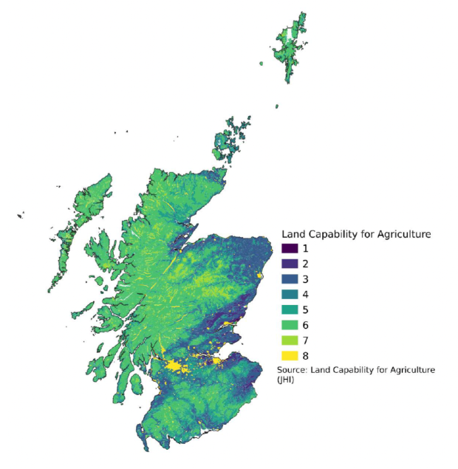
Source: Annex C. Maps - Agriculture and Rural Communities (Scotland) Bill: supporting evidence and analysis - gov.scot

Background reading
Brannan, T., Bickler, C., Hansson, H., Karley, A., Weih, M. and Manevska-Tasevska, G., 2023. Overcoming barriers to crop diversification uptake in Europe: A mini review. Frontiers in sustainable food systems, 7, p.1107700. Frontiers | Overcoming barriers to crop diversification uptake in Europe: A mini review
Carton, N., Swiergiel, W., Tidåker, P., Röös, E. and Carlsson, G., 2022. On-farm experiments on cultivation of grain legumes for food–outcomes from a farmer–researcher collaboration. Renewable Agriculture and Food Systems, 37(5), pp.457-467. On-farm experiments on cultivation of grain legumes for food – outcomes from a farmer–researcher collaboration | Renewable Agriculture and Food Systems | Cambridge Core
Cusworth, G., Garnett, T. and Lorimer, J., 2021. Agroecological break out: Legumes, crop diversification and the regenerative futures of UK agriculture. Journal of Rural Studies, 88, pp.126-137. Agroecological break out: Legumes, crop diversification and the regenerative futures of UK agriculture - ScienceDirect
Degieter, M., Gellynck, X., Goyal, S., Mattelin, M., De Wulf, J., Ott, D. and De Steur, H., 2023. A mixed-methods approach to examine farmers’ willingness to adopt protein crops. Outlook on Agriculture, 52(4), pp.446-456. A mixed-methods approach to examine farmers’ willingness to adopt protein crops - Margo Degieter, Xavier Gellynck, Shashank Goyal, Matis Mattelin, Jana De Wulf, Denise Ott, Hans De Steur, 2023
Degieter, M., Goyal, S., Gellynck, X., Brinks, H., Sanchez Garcia, L., Tobia, L., Ott, D. and De Steur, H., 2025. Environmental and economic sustainability of protein-rich crop cultivation in Europe. Outlook on Agriculture, p.00307270251371067. Environmental and economic sustainability of protein-rich crop cultivation in Europe - Margo Degieter, Shashank Goyal, Xavier Gellynck, Harm Brinks, Lucía Sánchez García, Leonardo Tobia, Denise Ott, Hans De Steur, 2025
Dergan, T., Ivanovska, A., Kocjančič, T., Iannetta, P.P. and Debeljak, M., 2022. ‘Multi-SWOT’Multi-Stakeholder-Based Sustainability Assessment Methodology: Applied to Improve Slovenian Legume-Based Agri-Food Chains. Sustainability, 14(22), p.15374. ‘Multi-SWOT’ Multi-Stakeholder-Based Sustainability Assessment Methodology: Applied to Improve Slovenian Legume-Based Agri-Food Chains
EUROLEGUME 2018. Final Report. Enhancing of legumes growing in Europe through sustainable cropping for protein supply for food and feed | FP7 | CORDIS | European Commission
Ferreira, H., Pinto, E. and Vasconcelos, M.W., 2021. Legumes as a cornerstone of the transition toward more sustainable agri-food systems and diets in Europe. Frontiers in Sustainable Food Systems, 5, p.694121. Frontiers | Legumes as a Cornerstone of the Transition Toward More Sustainable Agri-Food Systems and Diets in Europe
Fugeray-Scarbel, A. and Lemarié, S., 2024. The amplified effect of market size on innovation: A comparative analysis of pea and wheat seed value chains in France. Agricultural Systems, 219, p.104051. The amplified effect of market size on innovation: A comparative analysis of pea and wheat seed value chains in France - ScienceDirect
Iannetta, P.P., Hawes, C., Begg, G.S., Maaß, H., Ntatsi, G., Savvas, D., Vasconcelos, M., Hamann, K., Williams, M., Styles, D. and Toma, L., 2021. A multifunctional solution for wicked problems: value-chain wide facilitation of legumes cultivated at bioregional scales is necessary to address the climate-biodiversity-nutrition nexus. Frontiers in Sustainable Food Systems, 5, p.692137. Frontiers | A Multifunctional Solution for Wicked Problems: Value-Chain Wide Facilitation of Legumes Cultivated at Bioregional Scales Is Necessary to Address the Climate-Biodiversity-Nutrition Nexus
John Innes Centre 2020. Powering Pea Productivity. Powering-Pea-Productivity-report-web.pdf
Kezeya Sepngang, B., Muel, F., Smadja, T., Stauss, W., Stute, I., Simmen, M. and Mergenthaler, M. 2020. Report on legume markets in the EU. LegValue report. Microsoft Word - Report on legume markets in the EU-Fordchungsbericht.docx
Lara, S.W. and Ryan, P., 2025. The current state of peas in the United Kingdom; diversity, heritage and food systems. Plants, People, Planet. The current state of peas in the United Kingdom; diversity, heritage and food systems - Lara - 2025 - PLANTS, PEOPLE, PLANET - Wiley Online Library
Lybæk, R. and Hauggaard-Nielsen, H., 2023. A Qualitative Investigation of European Grain Legume Supply Markets through the Lens of Agroecology in Four Companies. Sustainability, 15(7), p.6103. https://www.mdpi.com/2071-1050/15/7/6103
Magrini, M.B., Anton, M., Chardigny, J.M., Duc, G., Duru, M., Jeuffroy, M.H., Meynard, J.M., Micard, V. and Walrand, S., 2018. Pulses for sustainability: breaking agriculture and food sectors out of lock-in. Frontiers in Sustainable Food Systems, 2, p.64. Frontiers | Pulses for Sustainability: Breaking Agriculture and Food Sectors Out of Lock-In
Mittag, F. and Hess, S., 2025. Can market fragmentation explain the limited success of political attempts to promote grain legume cultivation in Germany? Agricultural and Food Economics, 13(1), p.61. Can market fragmentation explain the limited success of political attempts to promote grain legume cultivation in Germany? | Agricultural and Food Economics
NCS 2025. From Soya to Sustainability. FSTS A4_v9_DIGITAL.pdf
Nicolson, W. and Jones, K. 2023. Putting beans on the plate Analysis of UK demand and supply of beans and plant-based proteins. 3Keel. Analysis of UK demand and value chain for plant-based foods, including beans
PGRO 2018. Blueprint for UK Pulses in a post-Brexit world. PGROBLUEPRINTFORPULSES.pdf
PGRO 2025. PULSE MARKET UPDATE - September / October 2025. PULSE MARKET UPDATE - September / October 2025 | PGRO
Redman, G., 2015. Revealing the opportunities for growing peas and beans in the UK. Report by the Andersons Centre. Microsoft Word - Potential of UK Pulses_080615_CD_clean-date DCS240615
van Loon, M.P., Alimagham, S., Pronk, A., Fodor, N., Ion, V., Kryvoshein, O., Kryvobok, O., Marrou, H., Mihail, R., Mínguez, M.I. and Pulina, A., 2023. Grain legume production in Europe for food, feed and meat-substitution. Global food security, 39, p.100723. Grain legume production in Europe for food, feed and meat-substitution - ScienceDirect
Voisin, R., Horwitz, P., Godrich, S., Sambell, R., Cullerton, K. and Devine, A., 2024. What goes in and what comes out: a scoping review of regenerative agricultural practices. Agroecology and Sustainable Food Systems, 48(1), pp.124-158. What goes in and what comes out: a scoping review of regenerative agricultural practices
Watson, C.A., Reckling, M., Preissel, S., Bachinger, J., Bergkvist, G., Kuhlman, T., Lindström, K., Nemecek, T., Topp, C.F., Vanhatalo, A. and Zander, P., 2017. Grain legume production and use in European agricultural systems. Advances in agronomy, 144, pp.235-303. Grain Legume Production and Use in European Agricultural Systems - ScienceDirect
Watson, C. & Murphy-Bokern, D. 2022. Legumes Translated Report 1 Actor group’s knowledge and insights into constraints and opportunities. Legumes-Translated-Report-1-2.pdf
Wiltshire, J., Freeman, D., Willcocks, J. and Wood, C., 2021. The potential for leguminous crops in Scotland. Ricardo Energy & Environment. The potential for leguminous crops in Scotland
Zander, P., Amjath-Babu, T.S., Preissel, S., Reckling, M., Bues, A., Schläfke, N., Kuhlman, T., Bachinger, J., Uthes, S., Stoddard, F. and Murphy-Bokern, D., 2016. Grain legume decline and potential recovery in European agriculture: a review. Agronomy for sustainable development, 36(2), p.26. Grain legume decline and potential recovery in European agriculture: a review - Archive ouverte HAL
Zhao, J., Chen, J., Beillouin, D., Lambers, H., Yang, Y., Smith, P., Zeng, Z., Olesen, J.E. and Zang, H., 2022. Global systematic review with meta-analysis reveals yield advantage of legume-based rotations and its drivers. Nature Communications, 13(1), p.4926. Review on the contribution of farming practices and technologies towards climate-smart agricultural outcomes in a European context - ScienceDirect

Annex B: Processing
Based on background reading listed at end and, where indicated, pers. comms. with stakeholders
- Prior to utilization as animal feed or human food, pulses require some processing. For on-farm ruminant animal feed, this can be as simple as sieving to remove contaminants. For example, soil and stones. However, particularly for monogastric animals, removal of the hulls and breaking the kernels improves digestibility and raises the relative protein content.
- Dehulling (aka decortication) is similarly required for human food utilization, removing some nutritional inhibitors (tannin). Subsequent splitting of the remaining kernel improves cooking properties and visual appeal.
- Efficient dehulling and splitting requires pulses to be of a more-or-less uniform size and shape, which is influenced by farm management but also by choice of variety. Varieties can also differ in hull adhesiveness and kernel brittleness, both of which affect wastage rates and usable processed yield. Hence the availability of appropriate varieties and advisory support for on-farm management improve subsequent processing performance.
- Dehulling and splitting can also be influenced by the moisture content of pulses. Whilst this can be manipulated immediately prior to dehulling, it is more usually controlled during storage of harvested and cleaned pulses. Storage prior to processing is commonly required, either on-farm or elsewhere, since the harvest window is narrow whilst processing plants need to operate for much of the year to be financially viable.
- Depending on the design of equipment, the competence of staff, and the quality of the pulses, multiple passes through equipment may be needed to achieve high levels of dehulling. Whilst dehulling alone may also split a proportion of kernels, higher success rates are achieved by subsequently using equipment designed purposively for splitting or equipment that combines both functions.
- Following dehulling and splitting, further cleaning is required to remove dust. For human consumption, grading/sorting to remove (e.g.) discolored or misshapen particles may also be desirable since it improves perceived quality. Cleaning and grading may involve gravity-assisted or air-flow sieving, or optical sorting.
- Subsequent storage on-farm may be in exposed heaps or silos, but bagging is possible with additional equipment. The same equipment can be used for animal feed and human food production, with British Retail Consortium (BRC) certification of the latter essentially only additionally requiring the use of stainless steel storage and demonstrable adherence to hygiene standards (pers comms.).
- Manufacturers of processing equipment confirm that the kit used for pea processing is also suitable for other pulses, such as faba beans. Moreover, it is also potentially suitable for other crops, such as cereals and oilseeds. This is very likely with respect to cleaning, grading and bagging (which only require minor calibrations to account for difference in kernel sizes). Depending on the design, it may or may not also be true for the dehulling/splitting stage as well (pers comms).
- Consequently, there is some potential for achieving economies of scale for a processing line by handling multiple crops in order to increase throughput. Moreover, equipment designed explicitly for regenerative agriculture can purposively handle multiple crops at the same time. For example, oats undersown with peas harvested together. However, care would need to be taken with respect to possible allergen cross-contamination in such cases.
- Although it is possible that small-scale primary processing occurs on some Scottish farms producing their own livestock feed, no commercial processing facilities for marketable animal feed or food grade purposes are identifiable within Scotland.
- However, manufacturers of processing equipment confirm that small-scale commercial processing is technically feasible and can be financially viable – although viability improves significantly with both daily throughput scale and proportion of the year in operation. Handling multiple crops can help in this regard, with faba beans being an obvious complementary line, but barley and oats also being possible candidates, as is hemp (coincidentally, also the subject of considerable interest within Scotland but similarly lacking in processing local facilities).
- The smallest-scale dehuller/splitter equipment has a throughput of c.0.25t/hour. Indicative costings suggest that this would require c.£20k+VAT in terms of design and installation plus c.£60k+VAT for the equipment (pers. comms). It has a relatively compact footprint and would be compatible with most farm circumstances (pers comms), but a shed would be required to house the equipment, and any pre and post-processing storage.
- An illustrative average yield of 3t/ha and an operational target of c.220 days/year implies c.150 ha of peas would need to be grown in Scotland for this purpose to justify this minimal level of processing investment. Diversifying to handle multiple crops (e.g. oats, hemp) would spread this requirement, but still need to involve a reasonable hectarage and by implication a reasonable number of individual farms. A formal cooperative structure might help to achieve this, potentially spreading funding and throughput obligations across a number of members around a centralized site with dedicated staffing (pers. comms).
- Alternatively, as under the ‘Give Peas a Chance!’ pilot, existing larger-scale processing facilities could be utilized under a service contact arrangement. This would cede some control in exchange for avoiding the need for upfront investment. Two possibilities may be envisaged.
- First, existing pulse processors close to Scotland, most obviously Pulse Processing Ltd at Belford in Northumberland, which already has relevant equipment and experience. Second, existing cereal (e.g. oats) processors in Scotland who might be interested in extending their operations to include pulses. In both cases, consideration would need to be given to the minimum acceptable consignment sizes and likely service charges (pers. comms).
- Dehulling and splitting may be regarded as primary processing, producing a lightly-modified pulse product for direct use. For example, on-farm feeding to livestock or incorporation into cookery recipes in the home or catering context. However, although not part of the ‘Give Peas a Chance!’ pilot, secondary processing is also possible with additional equipment.
- For example, milling pulses into flour generates another product can be sold direct to consumers and caterers, or to food manufacturers as an ingredient. It is particularly suitable for gluten-free baking, but also offers substitute binding properties for low-sugar reformulations.
- In addition, further processing by dry or wet fractionalization can be conducted to extract protein and starch concentrates or isolates. These serve as functional ingredients for incorporation into manufactured food products. For example, for protein fortification and extending shelf-life.
- Some such secondary processing does already occur in Scotland, albeit at a relatively small-scale. However, larger-scale secondary processing occurs elsewhere and indeed big investments (up to €100m) in large plants with high annual throughputs (>40 kt) have recently been announced in several European countries. This reflects the commodity nature of concentrates and isolates, and the likely economies of scale required for international markets.
- Figure 2 summarizes the various processing stages.
Background reading
BENEO 2025. BENEO inaugurates new pulse-processing plant Inauguration of new pulse-processing plant | BENEO
BRAED 2016. Business Opportunity: Pulse processing. BATTLE RIVER ALLIANCE FOR ECONOMIC DEVELOPMENT BRAED_Ag_Pulse_Case_2019_web_Final1.pdf
Buüler 2025 Peas - processing the protein of the future Dry Peas | Pulses Processing | Bühler Group
EIB 2025. Sweden: EIB supports plant protein factory Sweden: EIB supports plant protein factory, reducing the need for imports entering Europe
Food Business News 2022. New factory in Croatia to make plant-based ingredients New factory in Croatia to make plant-based ingredients | Food Business News
JK-Machinery 2025. Main series of machines. Comprehensive information on production lines and individual machine models JK Machinery - Machines (used in Sontag-Strohm et. al. below)
Malcolmson, L. and Han, J., 2019. Pulse processing and utilization of pulse ingredients in foods. In Health benefits of pulses (pp. 129-149). Cham: Springer International Publishing. Pulse Processing and Utilization of Pulse Ingredients in Foods | SpringerLink
Messina, V., Skylas, D.J., Roberts, T.H., Valtchev, P., Whiteway, C., Li, Z., Hopf, A., Dehghani, F., Quail, K.J. and Kaiser, B.N., 2025. Pulse proteins: Processing, nutrition, and functionality in foods. Foods, 14(7), p.1151. Pulse Proteins: Processing, Nutrition, and Functionality in Foods
Pulse Canada (undated) Recommended Best Practices for Pulse Processing Related Pre-Competitive Research https://21582500.hs-sites.com/hubfs/Best-Practices-for-Pulse-Research.pdf?hsCtaAttrib=189132886018
REDI 2022. Business Case for a Pea Processing Plant. Regional Economic Development Initiative. North West Alberta. Business Case for a Pea Processing Plant – REDI Region
Ratnayake, W.S. and Naguleswaran, S., 2022. Utilizing side streams of pulse protein processing: A review. Legume Science, 4(1), p.e120. Utilizing side streams of pulse protein processing: A review - Ratnayake - 2022 - Legume Science - Wiley Online Library
Seears, L. 2013. Understanding the Processing Supply Chain and Value Adding Opportunities for Pulse Industry. Nuffield Australia. 2013_AU_Lachie-Seears_Understanding-The-Processing-Supply-Chain-And-Value-Adding-Opportunities-For-The-Pulse-Industry.pdf
Sontag-Strohm, T., Stoddard, F., Laine, H. & Schauman, C. 2022. Dehulled grain legumes for food. Legumes Translated Dehulled grain legumes for food
USA Pulses. 2025. Processing Information and Technical Manual Introduction - USA Pulses
Wintone. 2025. Bean Processing Equipment. Pea Peeling, Splitting and Flour Milling Plant_Grain Processing Equipment
Figure B2: Summary of steps involved in primary and secondary processing of pulses
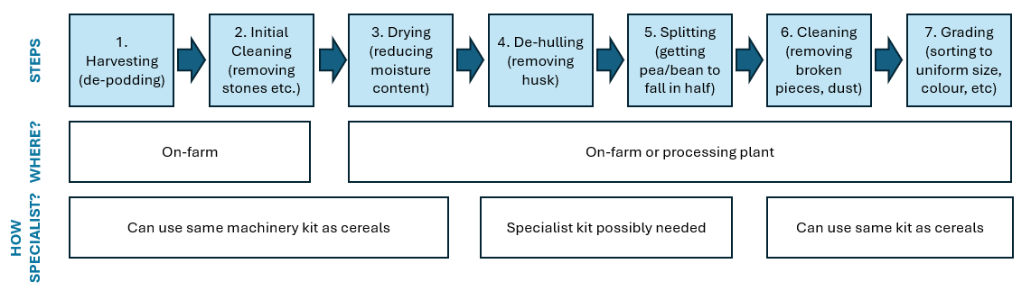

Table B1: Example identifiable existing and potential pulse processing facilities within and close to Scotland
Current status | Business name and location | Comment
Primary pulse processor | Pulse Processing Ltd, Belford | Sources 12kt faba beans from within UK, for salmon feed
Existing secondary pulse processors | Lapwing Community Mill, Stonehaven | Sources locally, but very low volumes
 | Osprio, Motherwell | Sources a few 00t of dehulled peas & beans outwith Scotland
 | Silvery Tweed Cereal, Berwick | Currently handling small volume from Pulse Processing Ltd
 | Mungoswells Farm, Drem | Currently handling small volume from Pulse Processing Ltd
Existing non-pulse primary processors | John Hogarth, Kelso | Organic-certified mill for oats and barley
 | Paragon, Peterhead | New company, processing organic oats
NB. non-pulse primary processors have not been contacted as part of this study, nor were Silvery Tweed and Mungowells Farm

Annex C: Consumption
Based on background reading listed at end and, where indicated, pers. comms. with stakeholders
- Consumption data for pulses, specific to Scotland, are not readily available. However, a breakdown of the types of pulses consumed by adults in Scotland was provided by Comrie et al, (2024), using data on dietary intake collected as part of the Scottish Health Survey (SHeS). (Figure C1).
- Figure C1. Percent of specific pulses and legumes types contributing to total pulse and legume intake amongst adults living in Scotland.
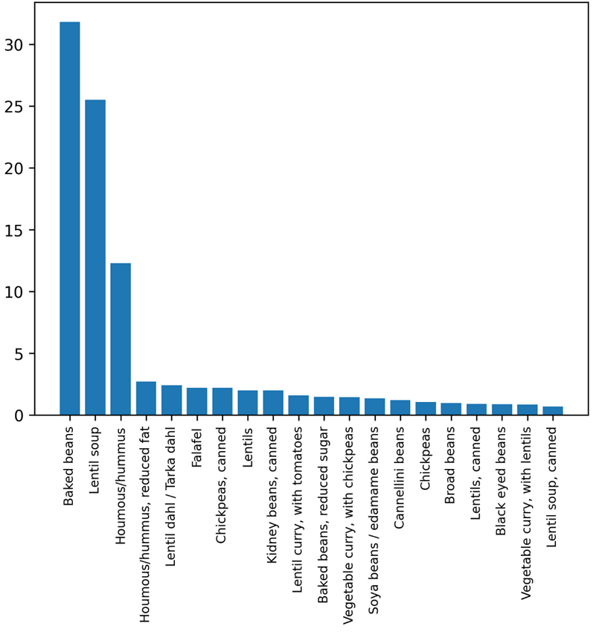
- Figure x shows that just over 30% of pulses and legumes are consumed as baked beans, followed by lentil soup (just over 25%) and houmous (12%). Remaining pulse and legume types represent very small percentages of overall intake.

- Whilst pulses were historically an important feature of the UK and Scottish diet, recent survey data (UK-wide, The Food Foundation, 2025) show average adult consumption of pulses at one portion (80g) per week.
- This rate falls well below the seven portions recommended by the EAT Lancet Planetary Health Diet. Primary school age children eat marginally more (1.2 portions per week), while teenagers and older adults eat less.
- Citizens from Asian backgrounds also eat relatively high quantities, as do high income consumers. Evidence is inconsistent about statistical significance of these differences, apart from citizen background/ethnicity.
- According to UK-wide survey data, the average person increased their spend on pulses from 70p per week in 2001 to £1.68 per week in 2022. The latter figure represents less than 1% of weekly income.
- Baked beans represent over a third of all pulse consumption for adults and over half for children. Other pulses are consumed in traditional, popular dishes such as soup (lentils), curries (chickpeas) and chilli (kidney beans). 95% of pulse consumption takes place inside the home, and half of this consumption is at the evening meal.
- In general, consumer awareness of the health benefits of pulses is high, and surveys indicate interest in eating more, even though intentions do not translate into behaviour. Beyond this, perceptions appear strongly aligned to underlying attitudes towards pulses.
- On one hand, consumers with positive attitudes regard pulses as convenient to cook, tasty and easy to add to their current diet, whereas sceptical consumers perceive pulses as difficult to cook, taste bland/boring, and lack knowledge about how to add them to their current diet. Consumers don’t know which dishes pulses appear in, even in ones they eat (e.g. 50% don’t know that dahl contains pulses).
- Willett et al (2024) undertook a study in which participants were given pulse-based recipes to try at home (with spending vouchers for ingredients), and were then interviewed to feedback on their experiences, and discuss their future consumption intentions.
- Around half the sample tried the recipes and reported positive experiences. Results showed participants wanted recipes that were easy to cook and involved ingredients, methods and dishes they were already familiar with. Participants who did not try the recipes did so out of habit/lack of motivation, and lack of perceived benefits to them.
- Willett et al’s results reinforce that, for many people, increased pulse consumption depends on practical aspects of convenience and familiarity, alongside increased awareness and knowledge of the health or environmental benefits of eating them. That study also makes the interesting observation that pulses occupy a hybrid category from a nutritional perspective, being both vegetables and protein ingredients in dishes. This appears to cause confusion/hesitancy for some consumers, as they are not sure about the appropriate frequency/amount of pulses to include in everyday eating, and whether/how to substitute pulses for other ingredients. Pulses also have a long-established association with vegetarian diets, which is a stigma for some consumer groups.
- In terms of actions that can be taken by industry, government and stakeholders, to increase pulse consumption:
- In 2025, The Food Foundation launched a ‘Keen Bean’ Commitment Framework, which invites retailers, manufacturers, catering companies and wholesalers to pledge to increase sales/servings of ‘beans’ (i.e. pulses and legumes) by a self-imposed target, by 2028. There are three levels of award, of which the highest, platinum, commits the company to doubling sales/servings of beans. The Framework provides a set of recommended actions, which include:
- Retailers: increasing the number of bean-based options within Meal Deal and food-on-the-go offers; include beans in ‘meal-for-tonight’ solutions’; increase space for promotion of beans outside of the canned aisle, e.g. gondola ends; use personalized promotions and deals on beans using loyalty card data; increase signage and use of call-outs on bean bays; increase the number of bean-based recipes and feature pieces on websites, in-store magazines, recipe cards and social media; include beans as part of any offers or in marketing for the Healthy Start scheme to low income consumers.
- Manufacturers: ensure beans are taken into consideration in NPD and reformulation strategies across all food categories; substitute some of the animal protein or carb within ready meals with beans. Pulse flour is currently being trialed in bread products in the UK.
- Caterers: increase the number of menu options containing beans; include beans as an optional add-on where menus provide options as a side (e.g. salad with beans); provide training/support to chefs to include beans in tasty meals; increase the number of bean-based meals on websites and social media; substitute beans in place of (some) animal protein in familiar dishes (e.g. burgers, chillis); use price nudging for online deliveries to incentivize purchase of bean options; introduce bean-based ‘specials’ or ‘seasonal dish of the day’ to menus.
- The World Resources Institute (Pollicino et al, 2024) has also produced a ‘food service playbook’ for promotion of more sustainable catering. Although the focus of this report is towards plant-rich catering rather than promotion of pulses and legumes specifically, the recommendations are relevant. Example actions recommended are:
- Product-related: arrange plant-rich dishes so that the more appealing ingredients are most visible (in terms of colour, garnishes, balance); increase the variety of plant-rich dishes
- Presentation-related: add environmental footprint labels to menus; avoid unappealing descriptors (e.g. meat-free, vegetarian); use indulgent language; make use of ‘chef specials’
- People-related: train chefs and food preparation staff in how to cook and prepare appealing plant-rich dishes.
- Promotion-related: create social media or other group forums where diners can share ideas, recommendations and reviews of plant-rich dishes; publicise the local benefits of dishes (where relevant) using marketing materials
- Price-related: run cross-promotions (e.g. meal deals) on selected dishes
- Of the above, it is the Product and Presentation actions which are proposed as most impactful, where the emphasis is on creating delicious food and talking about it in a taste-focused way, using indulgent language.
- Government encouragement (see also Annex D on protein strategies) for such private sector actions can be through supporting R&D and advisory capacity accessible by firms, funding support in the form of soft loans or grants, or deploying regulatory controls. Some potential sources of R&D and planning support or direct funding related to pulse markets include (pers. comms):
European Circular Innovation Valley
Innovate UK Business Connect – Agrifood Lead – Debbie Tully
Innovation Support | Accelerate Biotech Innovation Today — IBioIC
Interface Scotland – Inward Investment Catalyst
National Alternative Protein Innovation Centre (NAPIC)
ONE North East - SeedPod
Reformulation for Health | The Food & Drink Federation
UK Agritech Centre
Zero Waste Scotland
- It is also possible that the enterprise networks and/or Scottish Government itself may offer investment aid. For example, reinstatement of the Processing and Marketing Grant has been mooted (pers. comms.)
- More direct policy interventions are also possible. For example, Government itself could issue updated dietary guidance and/or information campaigns to emphasize the positive role of pulses (e.g. official dietary guidance does not currently recommend minimum pulse intake levels in the UK, but does in other countries). Equally, regulatory measures can also be used. For example, obliging healthier product formulations and (circular economy) waste reduction. Public procurement may also be used to increase consumer exposure to pulses and as an exemplar of what is possible, albeit constrained by procurement budgets.
- Animal feed outlets for domestic peas and beans face similar opportunities and challenges to those of human food outlets in terms of, for example, baseline ration formulation habits and a lack of awareness/familiarity with pulses as an alternative. This is reinforced by the challenges of pea and beans/ c.25% content being approximately half that of soya (pers. comms).
- Nonetheless, reflecting shifts in both consumer preferences and policy stances towards imported soya, these is some interest amongst Scottish suppliers of feed and amongst some Scottish livestock keepers to explore alternative feed sources, including domestically produced pulses. This may offer an easier route to scale than trying to develop human food outlets (pers. comms).
Background reading
Appleton, K.M., 2024. The importance of enjoyment, sensory properties and perceived cooking abilities in legume and pulse consumption: a questionnaire study. Public Health Nutrition, 27(1), p.e138. The importance of enjoyment, sensory properties and perceived cooking abilities in legume and pulse consumption: a questionnaire study | Public Health Nutrition | Cambridge Core
Auer, J., Östlund, J., Nilsson, K., Johansson, M., Herneke, A. and Langton, M., 2023. Nordic Crops as alternatives to soy—an overview of nutritional, sensory, and functional properties. Foods, 12(13), p.2607. Nordic Crops as Alternatives to Soy—An Overview of Nutritional, Sensory, and Functional Properties
David, L.S., Nalle, C.L., Abdollahi, M.R. and Ravindran, V., 2024. Feeding value of lupins, field peas, faba beans and chickpeas for poultry: an overview. Animals, 14(4), p.619. Feeding Value of Lupins, Field Peas, Faba Beans and Chickpeas for Poultry: An Overview
Guy, D.J., Bray, J. and Appleton, K.M., 2024. Select dietary changes towards sustainability: Impacts on dietary profiles, environmental footprint, and cost. Appetite, 194, p.107194. Select dietary changes towards sustainability: Impacts on dietary profiles, environmental footprint, and cost - ScienceDirect
Halmemies-Beauchet-Filleau, A., Rinne, M., Lamminen, M., Mapato, C., Ampapon, T., Wanapat, M. and Vanhatalo, A., 2018. Alternative and novel feeds for ruminants: nutritive value, product quality and environmental aspects. Animal, 12(s2), pp.s295-s309. Review: Alternative and novel feeds for ruminants: nutritive value, product quality and environmental aspects | animal | Cambridge Core
Henn, K., Goddyn, H., Olsen, S., Bredie, W. 2022. Identifying behavioural and attitudinal barriers and drivers to promote consumption of pulses: a quantitative survey across five European countries. Food Quality and Preference, 98: 104455. Identifying behavioral and attitudinal barriers and drivers to promote consumption of pulses: A quantitative survey across five European countries - ScienceDirect
Kaimila, Y, Olotu. O., Clegg, M., Jackson, K, Lovegrove, J. 2025. Pulse and legume consumption is associated with a more optimal nutrient intake and a higher EAT-Lancet index in a representative UK population. European Journal of Nutrition, 64: 139. Pulse and legume consumption is associated with a more optimal nutrient intake and a higher EAT-Lancet index in a representative UK population | European Journal of Nutrition
Kutepova, I., Rehm, C.D. and Friend, S.J., 2023. UK Chickpea Consumption Doubled from 2008/09–2018/19. Nutrients, 15(22), p.4784. UK Chickpea Consumption Doubled from 2008/09–2018/19
Lanza, M., Battelli, M., Gallo, L., Soglia, F., Bovera, F., Giunta, F., Primi, R., Biondi, L., Giannuzzi, D., Zampiga, M. and Addeo, N.F., 2025. Sustainability of Animal Production Chains: Alternative Protein Sources as an Ecological Driver in Animal Feeding: A Review. Animals, 15(22), p.3245. Sustainability of Animal Production Chains: Alternative Protein Sources as an Ecological Driver in Animal Feeding: A Review
Lisciani, S., Marconi, S., Le Donne, C., Camilli, E., Aguzzi, A., Gabrielli, P., Gambelli, L., Kunert, K., Marais, D., Vorster, B.J. and Alvarado-Ramos, K., 2024. Legumes and common beans in sustainable diets: nutritional quality, environmental benefits, spread and use in food preparations. Frontiers in Nutrition, 11, p.1385232 Global systematic review with meta-analysis reveals yield advantage of legume-based rotations and its drivers | Nature Communications
Lovegrove, J.A., O'Sullivan, D.M., Tosi, P., Millan, E., Todman, L.C., Bishop, J., Chatzifragkou, A., Clegg, M.E., Hammond, J., Jackson, K.G. and Jones, P.J., 2023. ‘Raising the Pulse’: The environmental, nutritional and health benefits of pulse‐enhanced foods. Nutrition Bulletin, 48(1), pp.134-143. ‘Raising the Pulse’: The environmental, nutritional and health benefits of pulse‐enhanced foods - Lovegrove - 2023 - Nutrition Bulletin - Wiley Online Library
Lovegrove, J.A., 2024. Benefits and challenges associated with ‘raising our daily pulses’. Nutrition Bulletin, 49(4), pp.425-428. Benefits and challenges associated with ‘raising our daily pulses’
Nasir, G., Zaidi, S., Tabassum, N. and Asfaq, 2024. A review on nutritional composition, health benefits and potential applications of by-products from pea processing. Biomass Conversion and Biorefinery, 14(10), pp.10829-10842. A review on nutritional composition, health benefits and potential applications of by-products from pea processing | Biomass Conversion and Biorefinery
Parrini, S., Aquilani, C., Pugliese, C., Bozzi, R. and Sirtori, F., 2023. Soybean replacement by alternative protein sources in pig nutrition and its effect on meat quality. Animals, 13(3), p.494. https://www.mdpi.com/2076-2615/13/3/494
Pollicino, D., Blondin, S., Attwood, S. 2024. The food service playbook for promoting sustainable food choices. Report. Washington DC: World Resources Institute. The Food Service Playbook for Promoting Sustainable Food Choices | World Resources Institute
Nicolson, W. and Jones, K. 2023. Putting beans on the plate Analysis of UK demand and supply of beans and plant-based proteins. 3Keel. Analysis of UK demand and value chain for plant-based foods, including beans
Oliveira, B., de Moura, A.P. and Cunha, L.M., 2019. Increasing pulse consumption to improve human health and food security and to mitigate climate change. Climate change-resilient agriculture and agroforestry: ecosystem services and sustainability, pp.21-35. Increasing Pulse Consumption to Improve Human Health and Food Security and to Mitigate Climate Change | SpringerLink
The Food Foundation 2025. Bean Facts: Available from: https://bit.ly/BeanFacts
Whittall, B., Warwick, M., Jackson, M., Appleton, K. 2024. Barriers and facilitators to consuming pulses: a qualitative exploration including effects of trying recipes at home. Journal of Nutritional Science, 16(6): 1-12. Barriers and facilitators to consuming pulses: a qualitative exploration including effects of trying recipes at home | Journal of Nutritional Science | Cambridge Core

Annex D: Protein strategies and supply-chain opportunities
Based on background reading listed at end and, where indicated, pers. comms. with stakeholders
- The European Commission has funded a succession of research studies into the potential for increasing the production and consumption of grain legumes across Europe. Similar studies have also been funded by other bodies, including within the UK and Scotland.
- Such studies have shown that the cultivation of pulses (grain legumes) as part of crop rotations offers public good environmental benefits as well as private production benefits. They also show that the consumption of pulses enhances human dietary-related health.
- For example, by reducing the need for artificial fertilizers and bought-in animal feed, peas and beans can lower pollutant loadings to air and water whilst also saving on input costs. Moreover, where animal feed and fertiliser are predominantly imported, domestic pulse production can reduce reliance upon trade.
- In some cases, import substitution may also address concerns about environmental damage in exporting countries. For example, as with soya beans imported from some South American countries.
- Domestic crop diversification also helps to support wider biodiversity and to reduce pest and disease burdens, further lowering required expenditure on chemical inputs. Equally, the nutritional profile of peas and beans contributes to a healthy human diet as a source of protein, fibre and various micronutrients.
- Studies into the feasibility of developing domestic grain legume supply-chains have identified opportunities and constraints. For example, the need to stimulate domestic demand for pulses, improve processing capacity, and encourage cultivation, all against a backdrop of path dependency/lock-in to a food system geared towards less crop diversity and reliance upon chemical inputs.
- Recognition of this has prompted some jurisdictions to introduce formal protein strategies as umbrella mechanisms for encouraging and co-ordinating greater domestic plant protein production, both for domestic consumption and potential export. Examples include Denmark, the Netherlands and Germany, with the European Union itself also putting support in place, not least to support ambitious targets for reducing nitrogen fertiliser usage. Non-European examples include South Korea, Manitoba in Canada, and Singapore (although some strategies encompass broader alternatives to animal protein, such as precision fermentation, as well as plant protein per se).
- The precise strategy details vary by jurisdiction. However, protein plans and strategies generally seek to reduce reliance on imported protein and the associated exposure to market volatility, whilst also positioning domestic production to capitalise on the global transition towards more sustainable proteins. They also deploy a mix of regulatory controls and funding mechanisms to encourage circular economy and/or bioeconomy innovations.
- For example, regulation may be used to oblige public sector procurement to favour domestic sources and to encourage food manufacturers and retailers to reformulate market offerings to increase consumer exposure to pulse-based products. Adjustments to dietary guidance and facilitation of information campaigns may also be supported.
- Equally, public funding in the form of soft loans, partial capital grants and R&D finance are often used to leverage-in private funding. Public funds are also used to support upstream R&D and advisory service capacity plus, in some cases, to directly subsidise cultivation of pulses. For example, Denmark (which has committed the most within the EU) has allocated c.£150m, of which c.£80m (over nine years) is for R&D, new product development and marketing, and c.£70m (over five years) is for direct aid to pulse growers.
- Evidence cited for the success of protein strategies mainly takes the form of increases in the area of pulses being cultivated, reductions in reliance upon imported feed and fertiliser, and investment in processing facilities (several very large processing plants have been announced). However, some academic studies have noted inconsistencies in definitions, measurements and attributions, and suggested that other influences are also at play. This is particularly the case for changes in consumer demand, with dietary guidance and information campaigns being generally regarded as relevant but weak levers for behavioural change.
- Although no part of Great Britain has yet to adopt a protein strategy, Northern Ireland has introduced a Protein Crop Payment of £330/ha to encourage cultivation. This followed a similar scheme in Ireland, where a more formal overarching strategy/plan has been proposed. Scottish stakeholders and/or stakeholders could consider drafting something similar (pers. comms.).
- The rationale for doing so is that the production and utilisation of pulses within Scotland would contribute towards a range of stated policy objectives. For example, the Agricultural and Rural Communities (Scotland) Act aims to simultaneously improve environmental conditions and farm profitability whilst producing high quality food, and the Good Food Nation (Scotland) Act seeks to improve Scottish diets whilst improving the diversity and profitability of Scottish farming (pers. comms.).
Background reading
AGROSYNERGIE 2019. Market developments and policy evaluation aspects of the plant protein sector in the EU. EC Report. Market developments and policy evaluation aspects of the plant protein sector in the EU - Publications Office of the EU
Clark, W. and Lenaghan, M. 2022. The Future of Food: Sustainable protein strategies around the world. Zero Waste Scotland. mf-ypo9m8yf-1678884875d
Cusworth, G., Garnett, T. and Lorimer, J., 2021. Agroecological break out: Legumes, crop diversification and the regenerative futures of UK agriculture. Journal of Rural Studies, 88, pp.126-137. Agroecological break out: Legumes, crop diversification and the regenerative futures of UK agriculture - ScienceDirect
Dade, C., Christensen, N. & Pittman, S. 2017. Spouted: The plant ingredient opportunity taking root on the prairies. Canada West Foundation. CWF_Sprouted_Report_WEB.pdf
Daera 2023. Q&A Protein Crops Scheme. Q&A Protein Crops Scheme | Department of Agriculture, Environment and Rural Affairs
Degieter, M., Goyal, S., Gellynck, X., Brinks, H., Sanchez Garcia, L., Tobia, L., Ott, D. and De Steur, H., 2025. Environmental and economic sustainability of protein-rich crop cultivation in Europe. Outlook on Agriculture, p.00307270251371067. Environmental and economic sustainability of protein-rich crop cultivation in Europe - Margo Degieter, Shashank Goyal, Xavier Gellynck, Harm Brinks, Lucía Sánchez García, Leonardo Tobia, Denise Ott, Hans De Steur, 2025
Dergan, T., Ivanovska, A., Kocjančič, T., Iannetta, P.P. and Debeljak, M., 2022. ‘Multi-SWOT’Multi-Stakeholder-Based Sustainability Assessment Methodology: Applied to Improve Slovenian Legume-Based Agri-Food Chains. Sustainability, 14(22), p.15374. ‘Multi-SWOT’ Multi-Stakeholder-Based Sustainability Assessment Methodology: Applied to Improve Slovenian Legume-Based Agri-Food Chains
Duluins, O. and Baret, P.V., 2024. A systematic review of the definitions, narratives and paths forwards for a protein transition in high-income countries. Nature Food, 5(1), pp.28-36. A systematic review of the definitions, narratives and paths forwards for a protein transition in high-income countries | Nature Food
EC 2024. Reducing the plant protein deficit of the European Union Reducing the plan protein deficit of the EU - European Commission
EC 2024. Member State Initiative. Reducing the plan protein deficit of the EU - European Commission
Elsalahy, H., Henchion, M., Abrahao, A., Lynch, R., Miserendino, G., Iachetti, A. and Reckling, M. 2022. Value chain gaps in plant-based protein production in Europe – A literature review. VALPRO. VALPRO-Path-Report-Gap-Analysis.pdf
EUROLEGUME 2018. Final Report. Enhancing of legumes growing in Europe through sustainable cropping for protein supply for food and feed | FP7 | CORDIS | European Commission
Ferreira, H., Pinto, E. and Vasconcelos, M.W., 2021. Legumes as a cornerstone of the transition toward more sustainable agri-food systems and diets in Europe. Frontiers in Sustainable Food Systems, 5, p.694121. Frontiers | Legumes as a Cornerstone of the Transition Toward More Sustainable Agri-Food Systems and Diets in Europe
Fugeray-Scarbel, A. and Lemarié, S., 2024. The amplified effect of market size on innovation: A comparative analysis of pea and wheat seed value chains in France. Agricultural Systems, 219, p.104051. The amplified effect of market size on innovation: A comparative analysis of pea and wheat seed value chains in France - ScienceDirect
GFI Europe 2021. Denmark announces 1 billion kroner for plant-based foods in historic climate agreement https://gfieurope.org/blog/denmark-plant-based-investment-in-climate-agreement/
Iannetta, P.P., Hawes, C., Begg, G.S., Maaß, H., Ntatsi, G., Savvas, D., Vasconcelos, M., Hamann, K., Williams, M., Styles, D. and Toma, L., 2021. A multifunctional solution for wicked problems: value-chain wide facilitation of legumes cultivated at bioregional scales is necessary to address the climate-biodiversity-nutrition nexus. Frontiers in Sustainable Food Systems, 5, p.692137. Frontiers | A Multifunctional Solution for Wicked Problems: Value-Chain Wide Facilitation of Legumes Cultivated at Bioregional Scales Is Necessary to Address the Climate-Biodiversity-Nutrition Nexus
Irish Protein Stakeholders Group 2025. STRATEGIC PLAN TO SUPPORT NATIVE PROTEIN PRODUCTION Layout 1
Lybæk, R. and Hauggaard-Nielsen, H., 2023. A Qualitative Investigation of European Grain Legume Supply Markets through the Lens of Agroecology in Four Companies. Sustainability, 15(7), p.6103. https://www.mdpi.com/2071-1050/15/7/6103
Magrini, M.B., Anton, M., Chardigny, J.M., Duc, G., Duru, M., Jeuffroy, M.H., Meynard, J.M., Micard, V. and Walrand, S., 2018. Pulses for sustainability: breaking agriculture and food sectors out of lock-in. Frontiers in Sustainable Food Systems, 2, p.64. Frontiers | Pulses for Sustainability: Breaking Agriculture and Food Sectors Out of Lock-In
Manners, R., Blanco-Gutiérrez, I., Varela-Ortega, C. and Tarquis, A.M., 2020. Transitioning European protein-rich food consumption and production towards more sustainable patterns—strategies and policy suggestions. Sustainability, 12(5), p.1962. Transitioning European Protein-Rich Food Consumption and Production towards More Sustainable Patterns—Strategies and Policy Suggestions
Mittag, F. and Hess, S., 2025. Can market fragmentation explain the limited success of political attempts to promote grain legume cultivation in Germany?. Agricultural and Food Economics, 13(1), p.61. Can market fragmentation explain the limited success of political attempts to promote grain legume cultivation in Germany? | Agricultural and Food Economics
Money, A., Srivastav, S. and Collett, K.A., 2022. The New Protein Economy: Policy Directions. Oxford Smith School of Enterprise and the Environment, 14, pp.2022-09. Oxford Smith School
Nicolson, W. and Jones, K. 2023. Putting beans on the plate Analysis of UK demand and supply of beans and plant-based proteins. 3Keel. Analysis of UK demand and value chain for plant-based foods, including beans
Oliveira, B., de Moura, A.P. and Cunha, L.M., 2019. Increasing pulse consumption to improve human health and food security and to mitigate climate change. Climate change-resilient agriculture and agroforestry: ecosystem services and sustainability, pp.21-35. Increasing Pulse Consumption to Improve Human Health and Food Security and to Mitigate Climate Change | SpringerLink
PGRO 2018. Blueprint for UK Pulses in a post-Brexit world. PGROBLUEPRINTFORPULSES.pdf
PGRO 2025. PULSE MARKET UPDATE - September / October 2025. PULSE MARKET UPDATE - September / October 2025 | PGRO
REDI 2022. Business Case for a Pea Processing Plant. Regional Economic Development Initiative. North West Alberta. Business Case for a Pea Processing Plant – REDI Region
Ratnayake, W.S. and Naguleswaran, S., 2022. Utilizing side streams of pulse protein processing: A review. Legume Science, 4(1), p.e120. Utilizing side streams of pulse protein processing: A review - Ratnayake - 2022 - Legume Science - Wiley Online Library
Redman, G., 2015. Revealing the opportunities for growing peas and beans in the UK. Report by the Andersons Centre. Microsoft Word - Potential of UK Pulses_080615_CD_clean-date DCS240615
Rogers, H., Dora, M., Tsolakis, N. and Kumar, M., 2024. Plant-based food supply chains: Recognising market opportunities and industry challenges of pea protein. Applied Food Research, 4(2), p.100440. Plant-based Food Supply Chains: Recognising Market Opportunities and Industry Challenges of Pea Protein - ScienceDirect
Röös, E., Bajželj, B., Smith, P., Patel, M., Little, D. and Garnett, T., 2017. Protein futures for Western Europe: potential land use and climate impacts in 2050. Regional Environmental Change, 17(2), pp.367-377. Protein futures for Western Europe: potential land use and climate impacts in 2050 | Regional Environmental Change
Scheuermann, M., Wood, A., Gordon, L.J., Röös, E. and Schultz, L., 2024. Leverage points for increased grain legume consumption: a Swedish case study. Renewable Agriculture and Food Systems, 39, p.e27. Leverage points for increased grain legume consumption: a Swedish case study | Renewable Agriculture and Food Systems | Cambridge Core
Seears, L. 2013. Understanding the Processing Supply Chain and Value Adding Opportunities for Pulse Industry The Journey from Gate to Plate. Nuffield Australia. 2013_AU_Lachie-Seears_Understanding-The-Processing-Supply-Chain-And-Value-Adding-Opportunities-For-The-Pulse-Industry.pdf
Tidåker, P., Potter, H.K., Carlsson, G. and Röös, E., 2021. Towards sustainable consumption of legumes: How origin, processing and transport affect the environmental impact of pulses. Sustainable production and consumption, 27, pp.496-508. Towards sustainable consumption of legumes: How origin, processing and transport affect the environmental impact of pulses - ScienceDirect
van Loon, M.P., Alimagham, S., Pronk, A., Fodor, N., Ion, V., Kryvoshein, O., Kryvobok, O., Marrou, H., Mihail, R., Mínguez, M.I. and Pulina, A., 2023. Grain legume production in Europe for food, feed and meat-substitution. Global food security, 39, p.100723. Grain legume production in Europe for food, feed and meat-substitution - ScienceDirect
Verza, M., Ceccacci, A., Frigo, G., Mulazzani, L. and Chatzinikolaou, P., 2024. Legumes on the Rise: The Impact of Sustainability Attributes on Market Prices. Sustainability, 16(7), p.2644. Legumes on the Rise: The Impact of Sustainability Attributes on Market Prices
Voisin, R., Horwitz, P., Godrich, S., Sambell, R., Cullerton, K. and Devine, A., 2024. What goes in and what comes out: a scoping review of regenerative agricultural practices. Agroecology and Sustainable Food Systems, 48(1), pp.124-158. What goes in and what comes out: a scoping review of regenerative agricultural practices
Watson, C.A., Reckling, M., Preissel, S., Bachinger, J., Bergkvist, G., Kuhlman, T., Lindström, K., Nemecek, T., Topp, C.F., Vanhatalo, A. and Zander, P., 2017. Grain legume production and use in European agricultural systems. Advances in agronomy, 144, pp.235-303. Grain Legume Production and Use in European Agricultural Systems - ScienceDirect
Watson, C. & Murphy-Bokern, D. 2022. Legumes Translated Report 1 Actor group’s knowledge and insights into constraints and opportunities. Legumes-Translated-Report-1-2.pdf
Wiltshire, J., Freeman, D., Willcocks, J. and Wood, C., 2021. The potential for leguminous crops in Scotland. Ricardo Energy & Environment. The potential for leguminous crops in Scotland
Zander, P., Amjath-Babu, T.S., Preissel, S., Reckling, M., Bues, A., Schläfke, N., Kuhlman, T., Bachinger, J., Uthes, S., Stoddard, F. and Murphy-Bokern, D., 2016. Grain legume decline and potential recovery in European agriculture: a review. Agronomy for sustainable development, 36(2), p.26. Grain legume decline and potential recovery in European agriculture: a review - Archive ouverte HAL

Of which, a high proportion (not reported in official statistics) will have been vining peas for freezing rather than field peas for drying and splitting.
The Food Foundation (2025) Bean Facts, Available from: https://bit.ly/BeanFacts.
Peas and beans contain natural anti-nutrients—primarily lectins, phytates, tannins, and protease inhibitors—that can interfere with nutrient absorption and cause digestive discomfort. Processing or domestic preparation (e.g. soaking, sprouting, boiling) significantly reduces such effects. A minority of consumers are intolerant to peas and beans.
The annual volume produced was c.3t, with c.2.4t supplied to Aberdeen City Council for school meals
Aberdeen City Council ran before-and-after surveys with catering staff, with results showing that training and encouragement led to a general (but not universal) increase in both their confidence to cook split-peas and enthusiasm for incorporating them into school menus.
See Dietary guidance for healthy and climate-friendly diets: a review of international evidence
The possible loss of an established environmental certification for imported soya may increase this pressure: Campaigners up in arms as soy traders leave deforestation moratorium | News | The Grocer & Retailers threaten soy traders over deforestation backtrack | The Grocer
See Supporting documents - Results from the Scottish Agricultural Census: June 2025 - gov.scot and Pesticide Usage in Scotland: Outdoor Vegetable Crops 2023 - gov.scot
See Lovegrove et al., (2023) but also Bread made from cell pulse flour keeps you fuller for longer | King's College London and Putting UK grown pulses back on the table and Our team - Raising the Pulse of our daily bread

