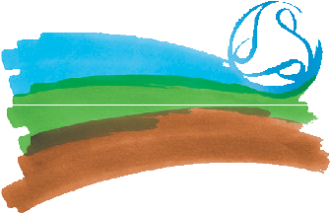
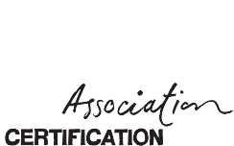
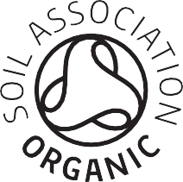

Labelling Guide

Rules for labelling of retail packed organic products

This document is aimed at supplementing the Soil Association standards on labelling (5.8), by providing visual examples and some further clarification on changes since Brexit. Please refer to the SA standards for the full guidance on labelling. (*Top tip: use the contents page of our standards, or CTRL+F to search the standard reference.)

The information provided in this guide relates to organic labelling requirements only. It is your responsibility to ensure your labels comply with any other legal requirements.
Please submit labels to food.drink@soilassociation.org for approval prior to printing to ensure they meet the requirements.

Products packed in GB (England, Wales, Scotland):
This applies to retail products packed in GB and certified to the GB organic regulation (Retained Regulation No. 834/2007 & 889/2008), or Soil Association’s higher standards where applicable.

The mandatory organic information explained in this guide must be on the outside of retail packaging. E.g. it cannot be on the inside lid of a box.

These labelling requirements apply to products packed in GB to be placed on GB, EU and NI markets. For export to any other market, please check labelling requirements with your customer and their certification body. Some markets may have additional or different requirements (e.g. South Korea will not accept the EU logo for products packed in GB).

Please see our guidance on exporting here.

The following label requirements apply:

Certification code
- GB-ORG-05 where packed by a Soil Association licensee. (If packed by a business certified by another GB certification body, it would be their certifier code instead).
- Refer to Soil Association standards 5.4.6 & 5.8.2 for further conditions.

UK Statement of Agricultural Origin
- You must include one of the following statements on new labels on all organic retail products packaged in Great Britain which accurately reflects where the ingredients were grown or farmed.

This statement should read:

UK Agriculture – if 98% or more of the ingredients were grown in the UK

Non-UK Agriculture – if 98% or more of the ingredients were grown outside of the UK

UK/Non-UK Agriculture – If some of the ingredients were grown in the UK and some were grown outside the UK

Single Origin Statement – if 98% of the ingredients were grown in one country, you may reference that country, e.g. Indian Agriculture.

- There is no requirement for where the UK agriculture statement appears, but it is recommended in the same visual field as the certification code.
- Please note the statement must reference UK, and GB cannot be used as an alternative.
- You may reference “Welsh Agriculture” “Scottish Agriculture” “English Agriculture” if you are using a single origin statement where 98% of the ingredients were farmed or grown in those regions. However “GB Agriculture” or “British Agriculture” would not be permitted.
- See Soil Association standards 5.8.7.

Please note, this requirement is for products packed in GB. If the product is packed in EU, it does not need the addition of the UK statement and can just have the EU agriculture statement.

Soil Association Symbol
- This symbol should only be used on products certified to Soil Association Higher Standards and cannot be placed on products certified only to GB organic regulations.
- Refer to Soil Association standards 5.8.3 and 5.8.8 for further conditions of use.
- Downloadable versions of the symbol are available from our website here Soil Association Logo.
- If a company certified by another certification body is labelling the product on your behalf with the Soil Association symbol, you will require a ‘Contracted Symbol User’ (CSU) agreement. Please ask a certification officer for more details.

EU logo
- The EU leaf logo is optional for products produced/manufactured/labelled in GB.
- If your product is retail packed in the EU or NI, it must have the EU leaf logo.
- Refer to Soil Association standards 5.8.6 for further conditions of use.

EU agricultural statement

- If you choose to use the EU organic logo on your label, it must also include an EU agricultural statement (in addition to the UK statement where packed in GB), which should read:

EU agriculture – if 98% or more of the ingredients were grown in the EU

Non-EU Agriculture – if 98% or more of the ingredients were grown outside the EU

EU/Non-EU Agriculture – if some ingredients were grown in the EU and some outside the EU

Single Origin Statement – if 98% of the ingredients were grown in one country you may reference that country e.g. Indian Agriculture

- The EU agricultural statement must be in the same visual field as the EU logo and must be immediately below the certifier code (with no other text in-between).
- Please refer to Soil Association standards 5.8.7 for further conditions of use.

Please refer to Soil Association standards 5.8.2 for information on the ingredients list and traceability code

Examples
1.
- Product which meets the Soil Association higher standards (use of SA symbol).
- Is labelled by a Soil Association certified company in GB (code GB-ORG-05).
- 98% of the ingredients were grown in the UK.
- This product does not use the EU leaf logo as it is optional for products packed in GB.

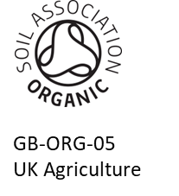

2.
- Product which meets GB (EU) organic standards only, not the Soil Association higher standards.
- Is labelled by an Italian company certified by an Italian certification body (code IT-BIO-009).
- Some ingredients were grown in the EU, some ingredients were grown in India.
- Does not require the UK statement of agriculture as packed in EU.

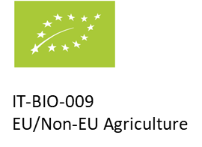

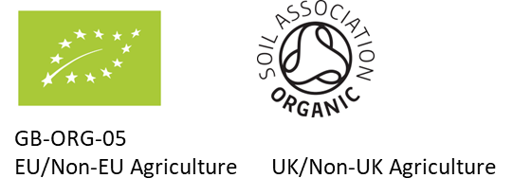
3.
- Product meets Soil Association higher standards (use of SA logo).
- Is labelled by Soil Association licensee in GB (code GB-ORG-05).
- Chosen to include the EU leaf logo and therefore must use both UK and EU statement of agriculture.
- EU statement directly below certification code (GB-ORG-05).
- Ingredients are grown in the EU, UK, and outside the EU.

- Product which meets the Soil Association higher standards (use of SA symbol).
- Is labelled by a Soil Association certified company in GB (code GB-ORG-05).
- 98% of the ingredients were grown in France, therefore only one statement of agriculture is required.
- Have chosen to include the EU leaf logo.
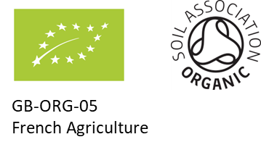
4.

Products Packed in Northern Ireland

Businesses in Northern Ireland will continue to be certified to EU regulation (EC reg 2018/848).

Therefore, there are some differences for labelling products in Northern Ireland compared to GB. Please read the differences for labelling in Northern Ireland below. Apart from these differences, the same labelling requirements (already outlined in this guide) will apply.

Certification Code
- The certification codes for Northern Ireland are being changed by the European Commission. The code for Soil Association Certification licensees in Northern Ireland will be XI-ORG-05. If you are looking at printing labels in the near future, consider changing the certification code to XI-ORG-05, or print a smaller number of labels to allow you to accommodate changes to labelling sooner. Operators were originally given until September 2024 to amend; this has now been extended to 1st December 2024. Please continue to follow updates on cert news.

EU logo/ EU agricultural statement
- Products retail packed in Northern Ireland must carry the EU leaf logo and therefore must carry the accompanying EU agricultural statement (EU Agriculture/Non-EU Agriculture/EU & Non-EU Agriculture as applicable).

- The EU agricultural statement must be in the same visual field as the EU logo and must be directly below the certifier code.

- If all the agricultural raw materials, (at least 95%), have been farmed in Northern Ireland then the operator may identify them with either of the following:
- UK (NI) Agriculture
- United Kingdom (Northern Ireland) Agriculture
- EU Agriculture
- The phrases ‘Northern Ireland Agriculture’ and ‘UK (Northern Ireland) Agriculture’ should not be used. The above will apply to goods placed on the market from 2 December 2024 onwards (anything packed and labelled available for sale prior to 02/12/24 can be sold until stocks are exhausted).

- If the product consists of >95% agricultural ingredients from any individual country, ‘EU agriculture’ or ‘non-EU agriculture’ can be replaced with the name of that country (NB under EC reg 2018/848 the % of ingredients from a single region/country has reduced from 98% to 95%).

- If ingredients for your product are produced within GB, you will need to ensure the statement of agriculture reflects non-EU origin (see example 3 below).

- Please refer to Soil Association standards 5.8.7 for further conditions of use.
Examples:

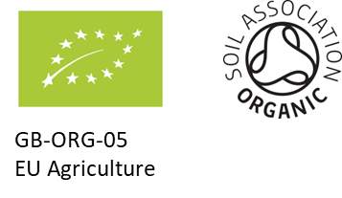
1.
- Product which meets the Soil Association higher standards (use of SA logo).
- Is labelled by a Soil Association certified company (code GB-ORG-05).
- Ingredients were grown in the EU.
- Product will be packed and labelled in Northern Ireland.

2.
- Product which meets EU Organic Standards only, but not the Soil Association higher standards.
- Is labelled by a non-Soil Association certified company (code GB-ORG-07).
- Some ingredients were grown in the EU and some ingredients were grown in the UK.
- Product will be packed and labelled in Northern Ireland.

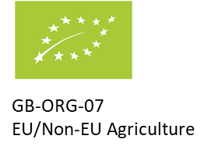

3.
- Product which meets Soil Association higher standards (use of SA logo).
- Is labelled by a Soil Association certified company (code GB-ORG-05).
- Product packed and labelled in Northern Ireland.
- Non-EU agriculture statement can reflect ingredients grown both in GB and other non-EU countries.

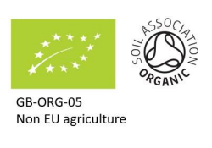

For labelling requirements for non-retail packed products, please refer to Soil Association standards 5.14.2

